Repeated Modular Arrangement

Definition
# Source: AI Source: Provided by: [Data Path: Persons Table -> ID Column: 1, Name_En Column: Motasem Essam] -> From: [ChatGPT] on [7/25/2026]
A Repeated Modular Arrangement is a type of composite solid arrangement in which two or more identical or compatible solid modules are repeated and connected according to a consistent geometric pattern to form a larger three-dimensional structure.
Each module acts as a basic building unit that can be combined with other modules through matching faces, edges, connection points, or designated interfaces.
The arrangement can extend horizontally, vertically, in multiple directions, or through more complex three-dimensional configurations.

Simple Definition
# Source: AI Source: Provided by: [Data Path: Persons Table -> ID Column: 1, Name_En Column: Motasem Essam] -> From: [ChatGPT] on [7/25/2026]
A repeated modular arrangement is a composite solid made by connecting repeated geometric units according to a consistent arrangement pattern.

Geometric Representation
# Source: AI Source: Provided by: [Data Path: Persons Table -> ID Column: 1, Name_En Column: Motasem Essam] -> From: [ChatGPT] on [7/25/2026]
Repeated modular arrangements can be constructed using cubes, rectangular prisms, cylinders, pyramids, or specially designed geometric modules.
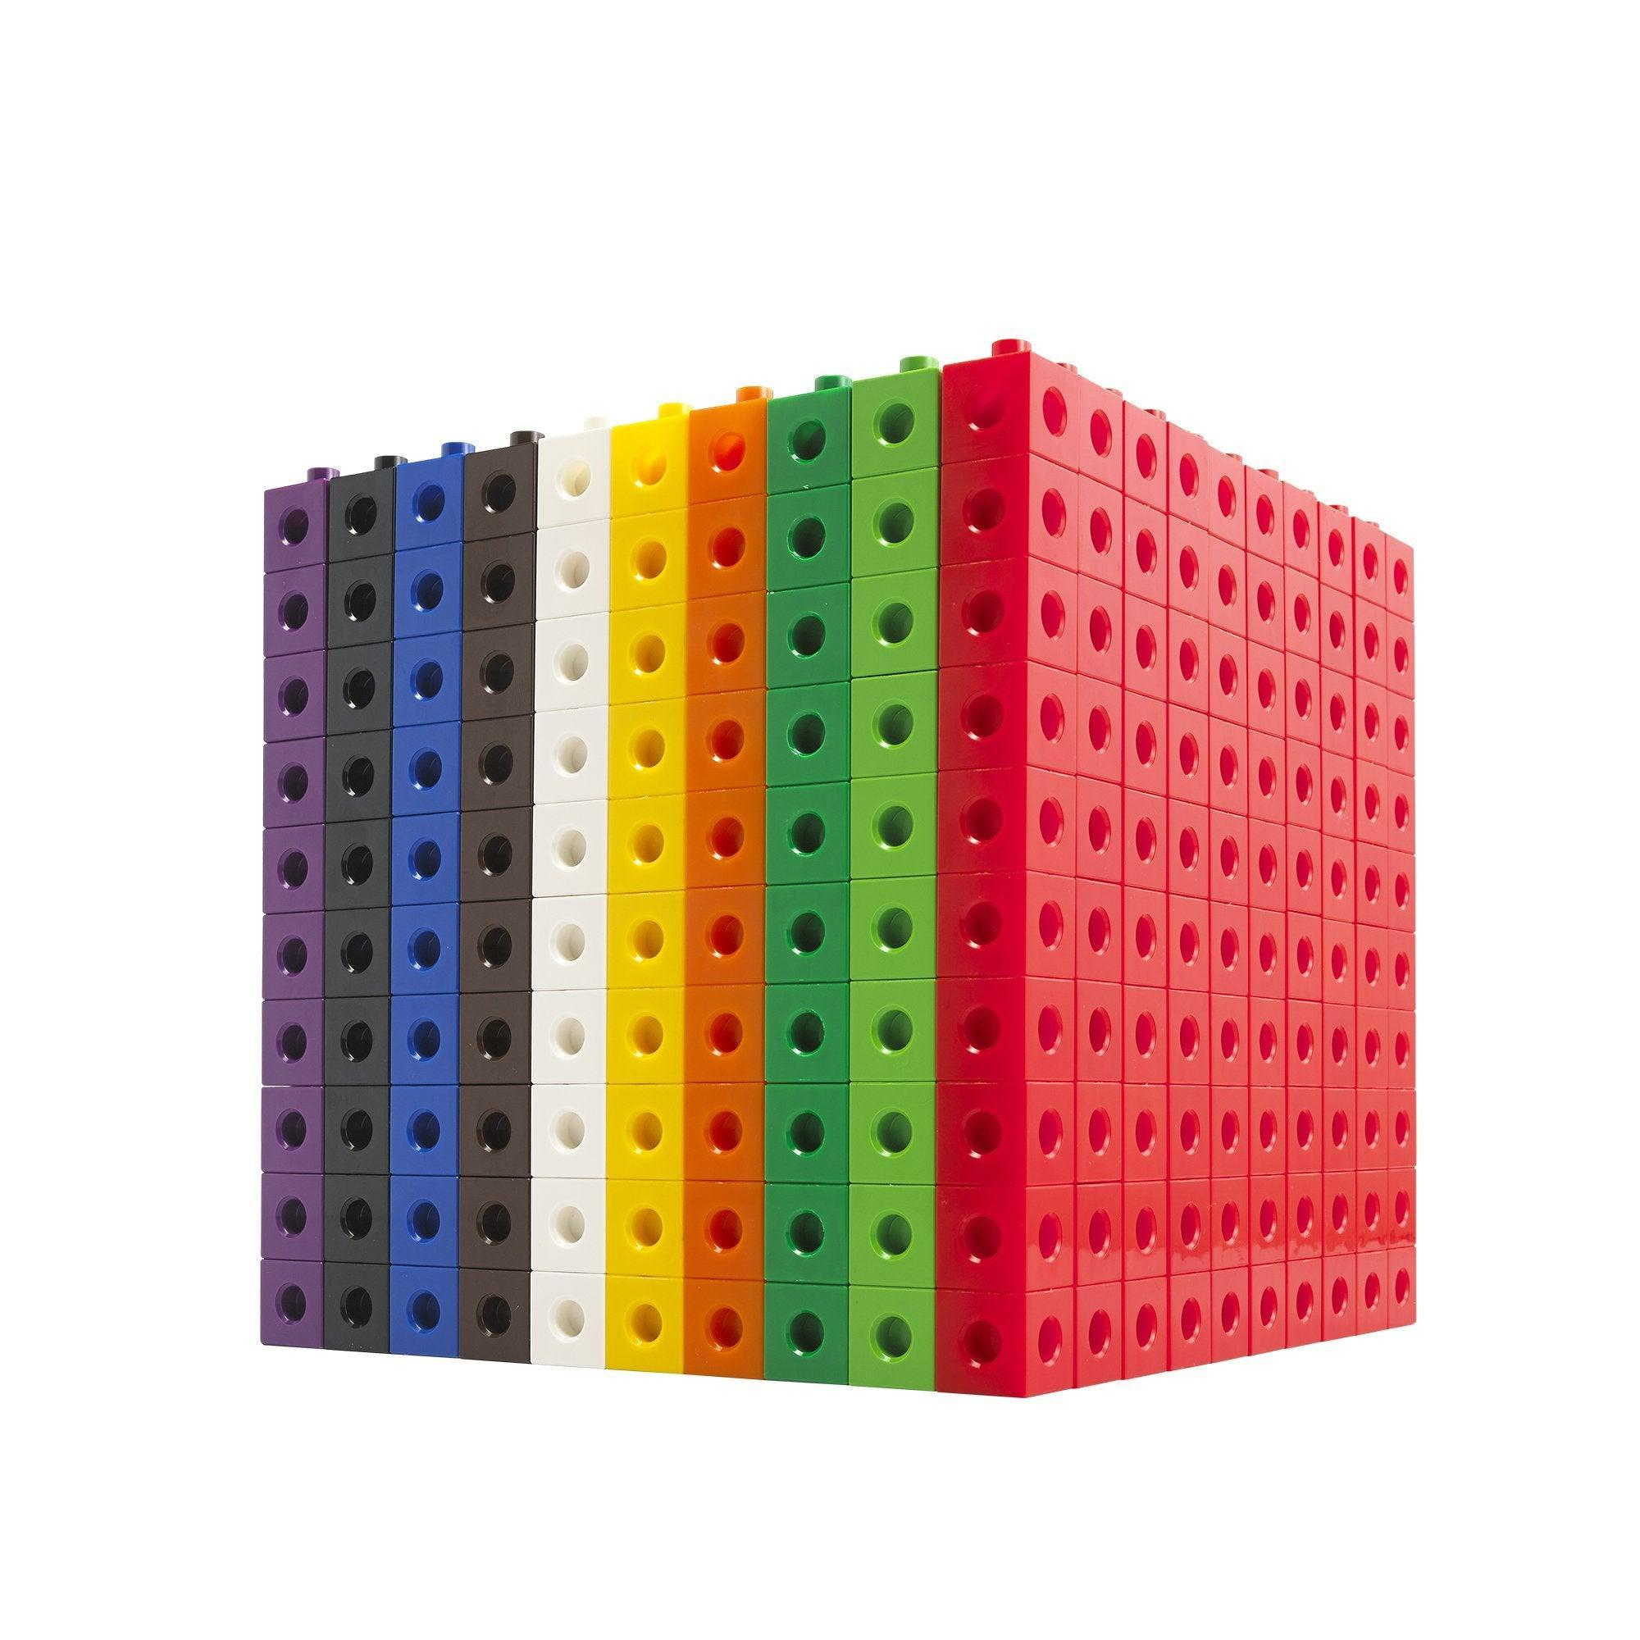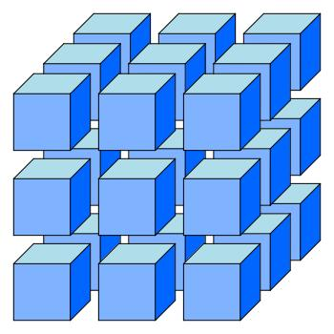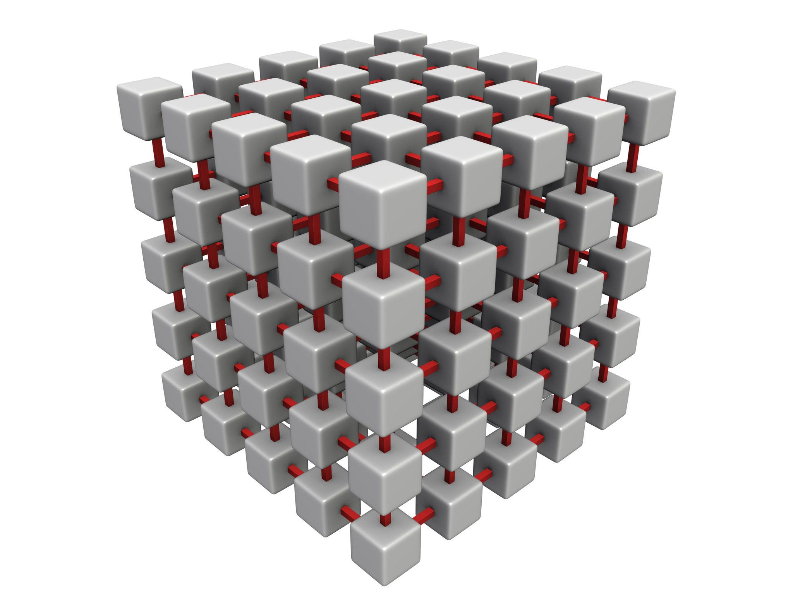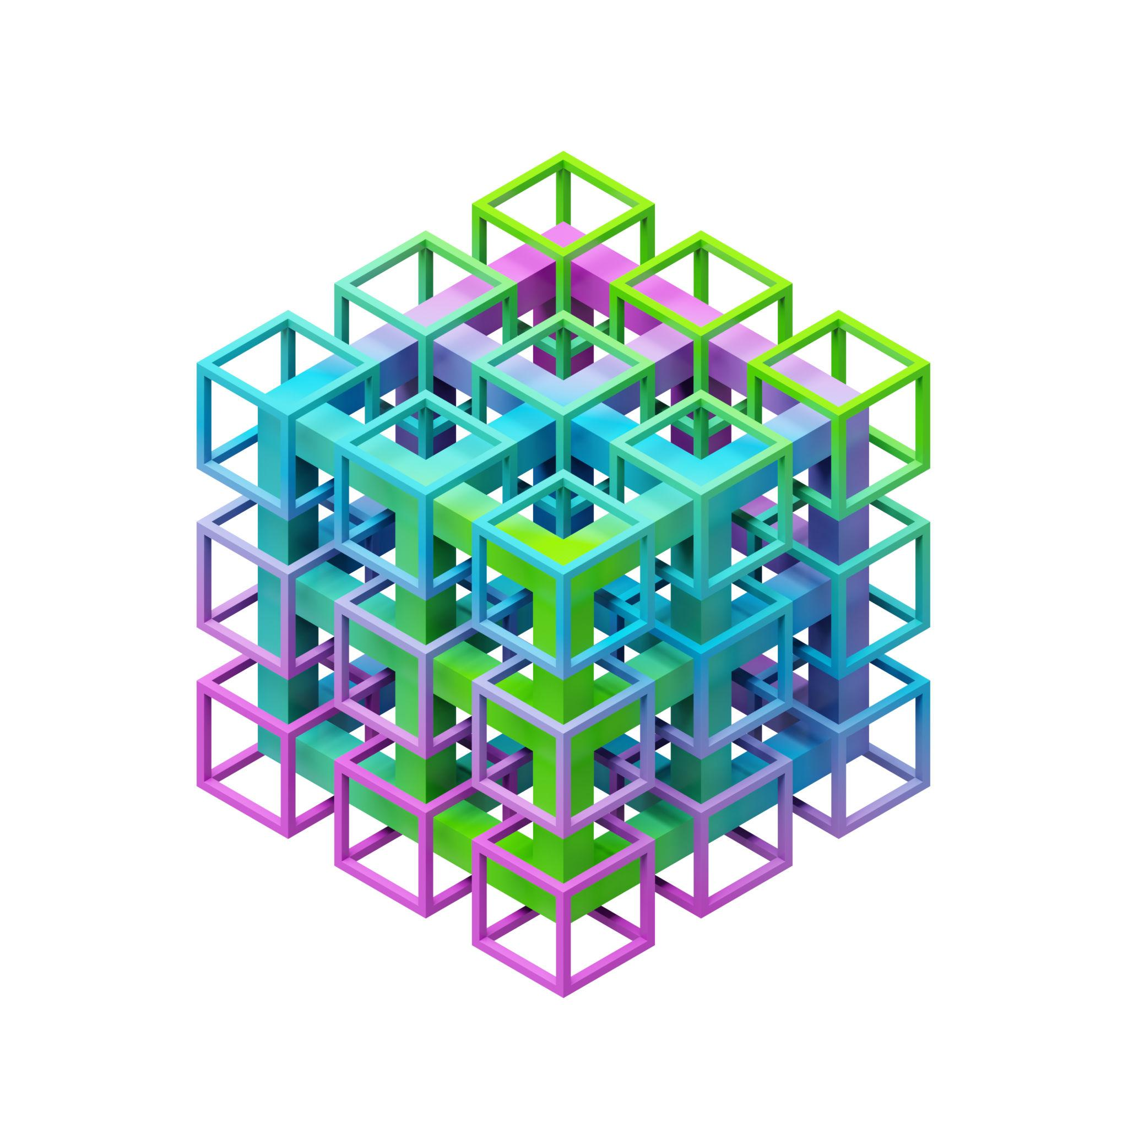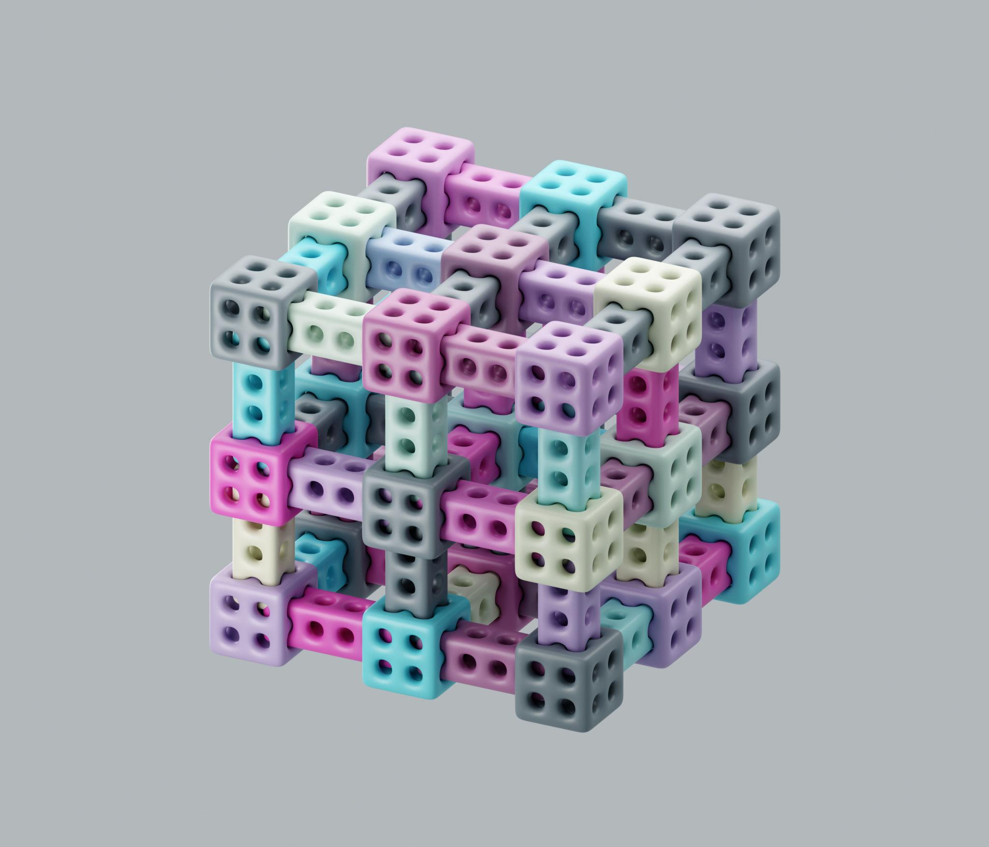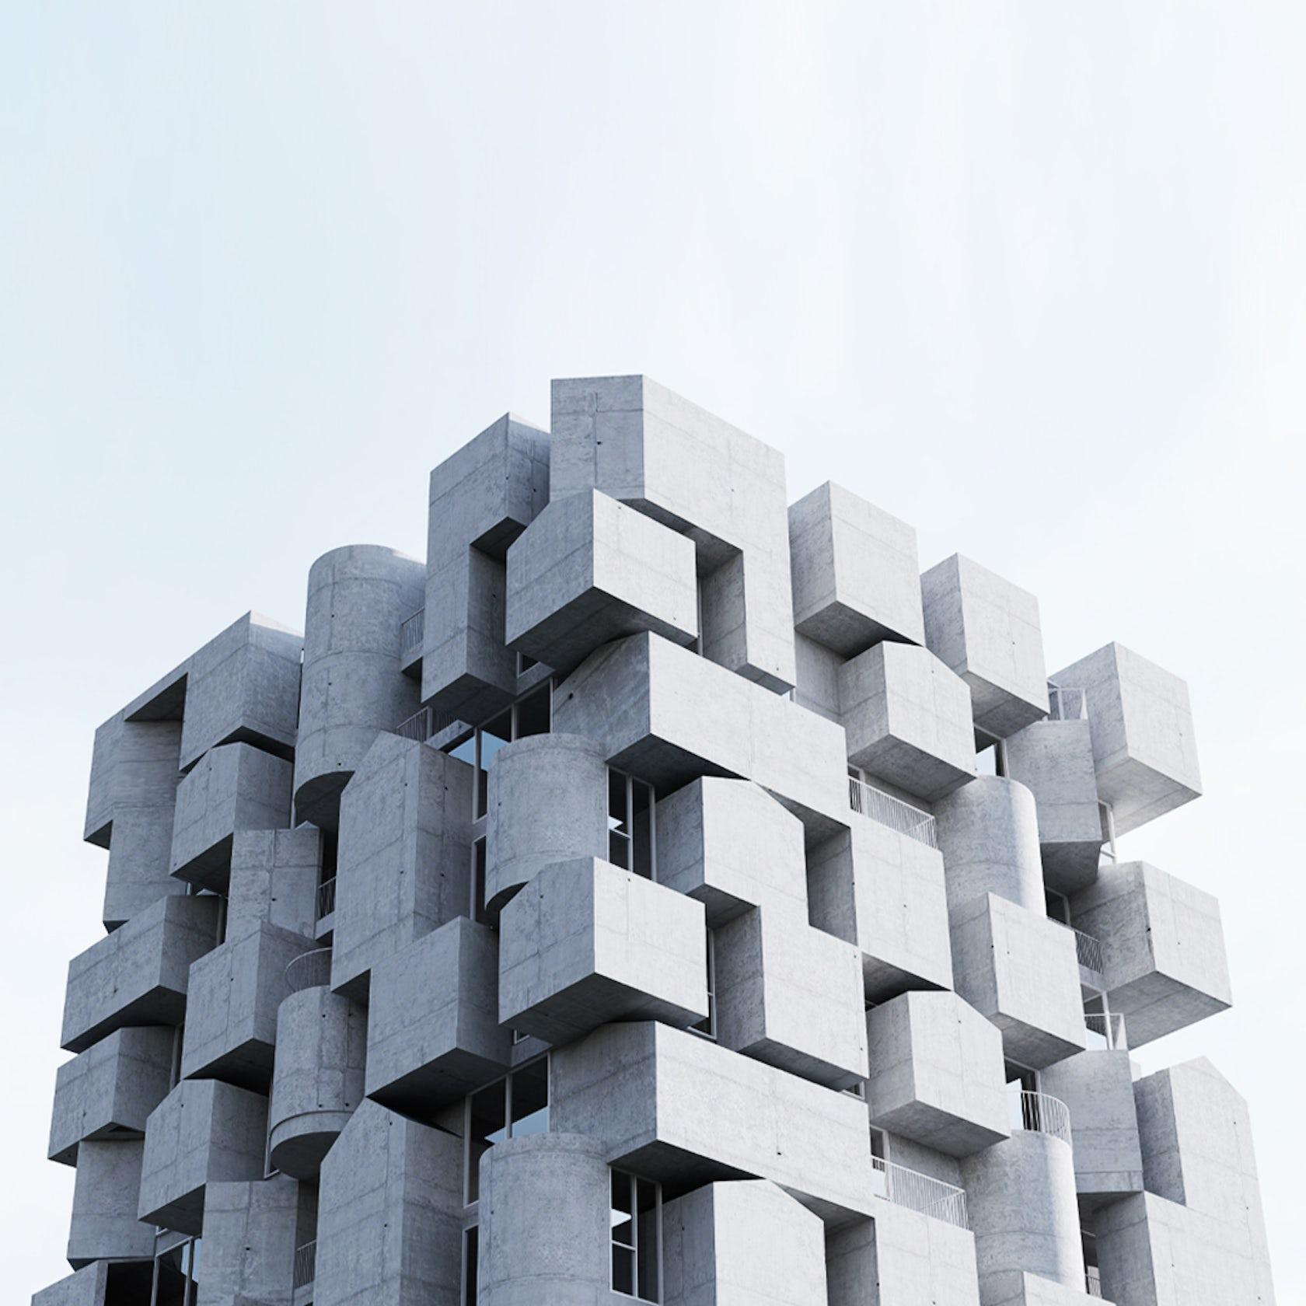
Main geometric elements:
- Module: The basic solid unit repeated throughout the structure.
- Repeated Components: Multiple copies of the same module or compatible modules.
- Connection Interface: The surface, edge, or designated region where modules connect.
- Module Orientation: The direction in which each module is positioned.
- Arrangement Pattern: The geometric rule used to organize the repeated modules.
- Composite Structure: The complete three-dimensional object formed by combining the modules.

Main Classification
# Source: AI Source: Provided by: [Data Path: Persons Table -> ID Column: 1, Name_En Column: Motasem Essam] -> From: [ChatGPT] on [7/25/2026]
Repeated modular arrangements can be classified according to their connection patterns, repetition directions, module configurations, and geometric properties.

Classification by Repetition Direction
# Source: AI Source: Provided by: [Data Path: Persons Table -> ID Column: 1, Name_En Column: Motasem Essam] -> From: [ChatGPT] on [7/25/2026]
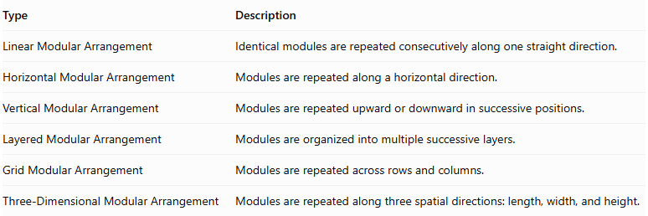
Type | Description
Linear Modular Arrangement | Identical modules are repeated consecutively along one straight direction.
Horizontal Modular Arrangement | Modules are repeated along a horizontal direction.
Vertical Modular Arrangement | Modules are repeated upward or downward in successive positions.
Layered Modular Arrangement | Modules are organized into multiple successive layers.
Grid Modular Arrangement | Modules are repeated across rows and columns.
Three-Dimensional Modular Arrangement | Modules are repeated along three spatial directions: length, width, and height.
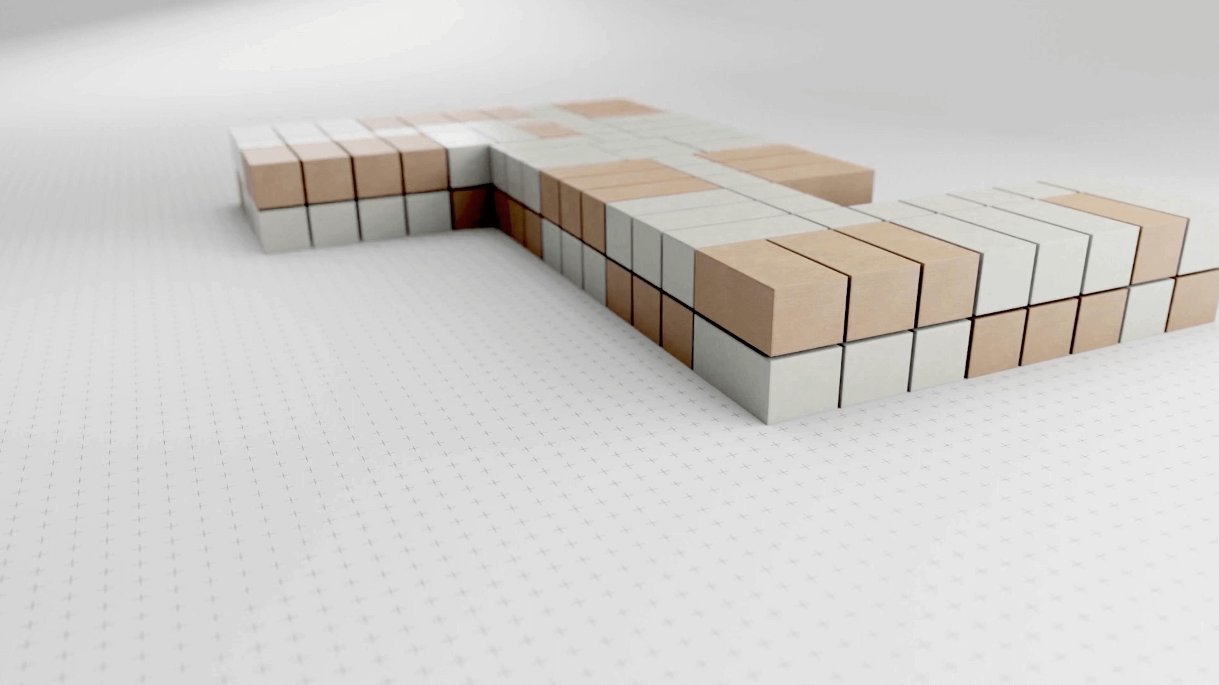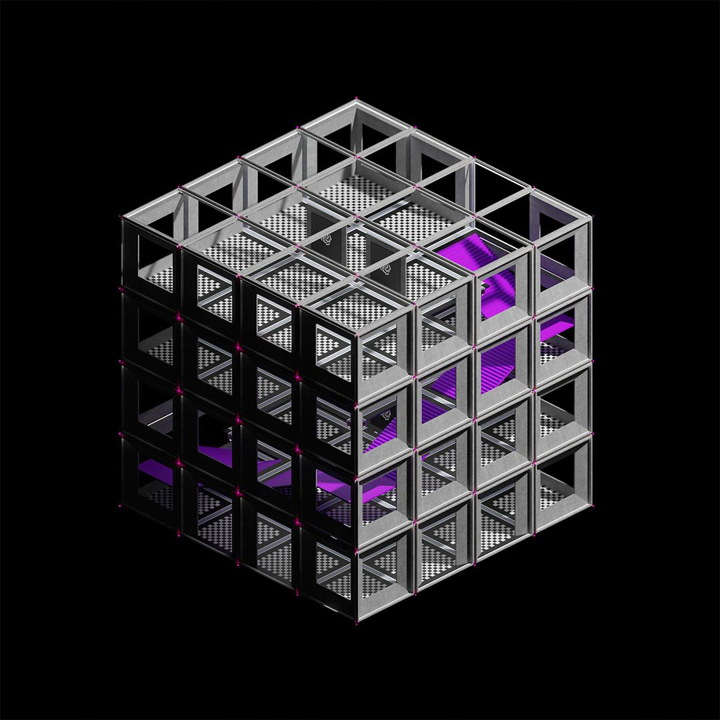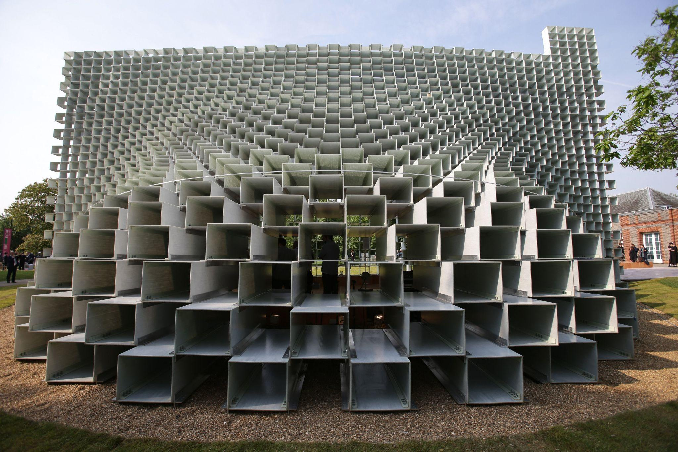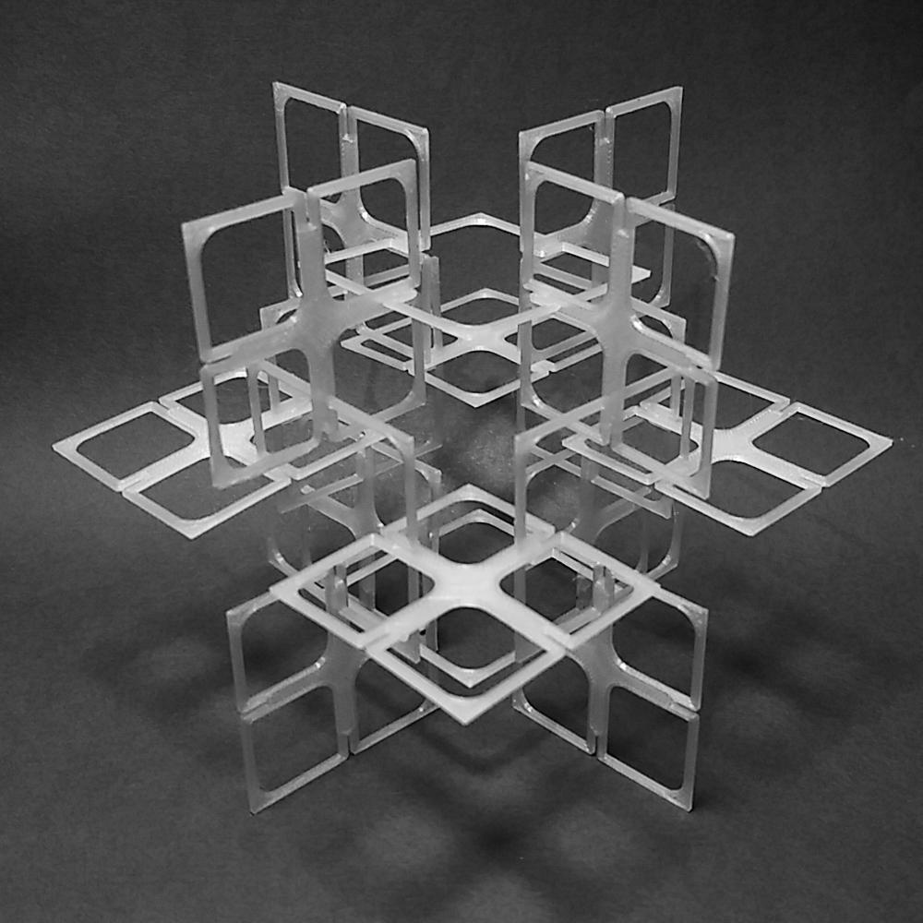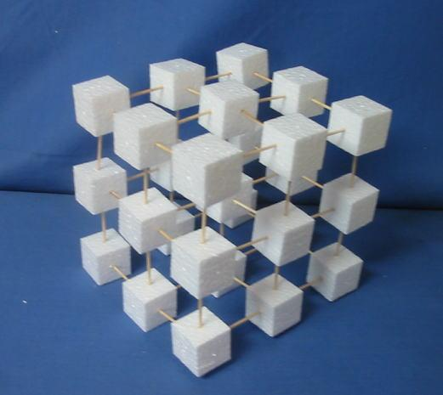

Classification by Connection Pattern
# Source: AI Source: Provided by: [Data Path: Persons Table -> ID Column: 1, Name_En Column: Motasem Essam] -> From: [ChatGPT] on [7/25/2026]
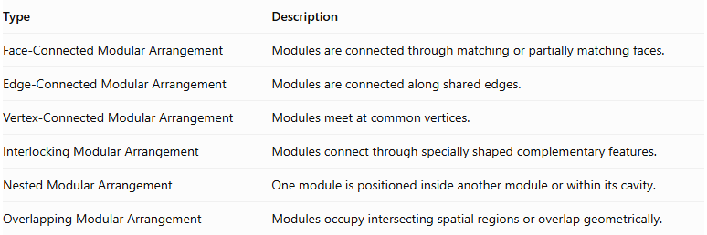
Type | Description
Face-Connected Modular Arrangement | Modules are connected through matching or partially matching faces.
Edge-Connected Modular Arrangement | Modules are connected along shared edges.
Vertex-Connected Modular Arrangement | Modules meet at common vertices.
Interlocking Modular Arrangement | Modules connect through specially shaped complementary features.
Nested Modular Arrangement | One module is positioned inside another module or within its cavity.
Overlapping Modular Arrangement | Modules occupy intersecting spatial regions or overlap geometrically.
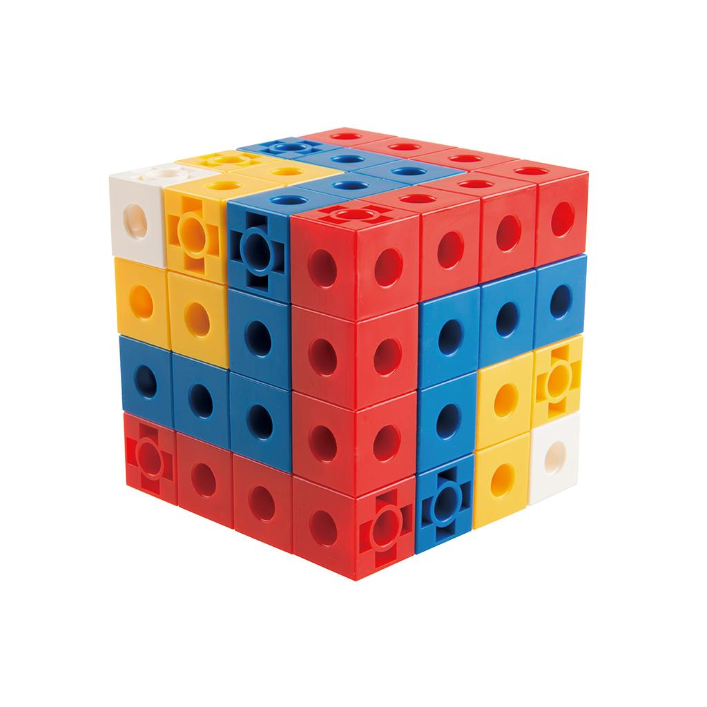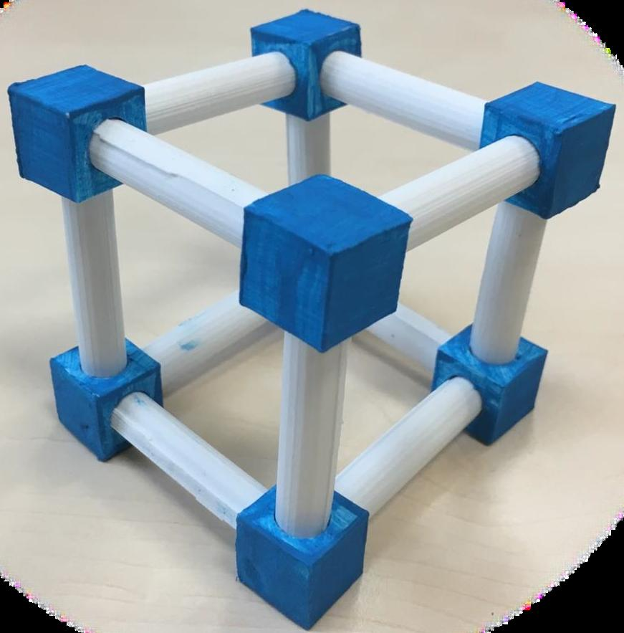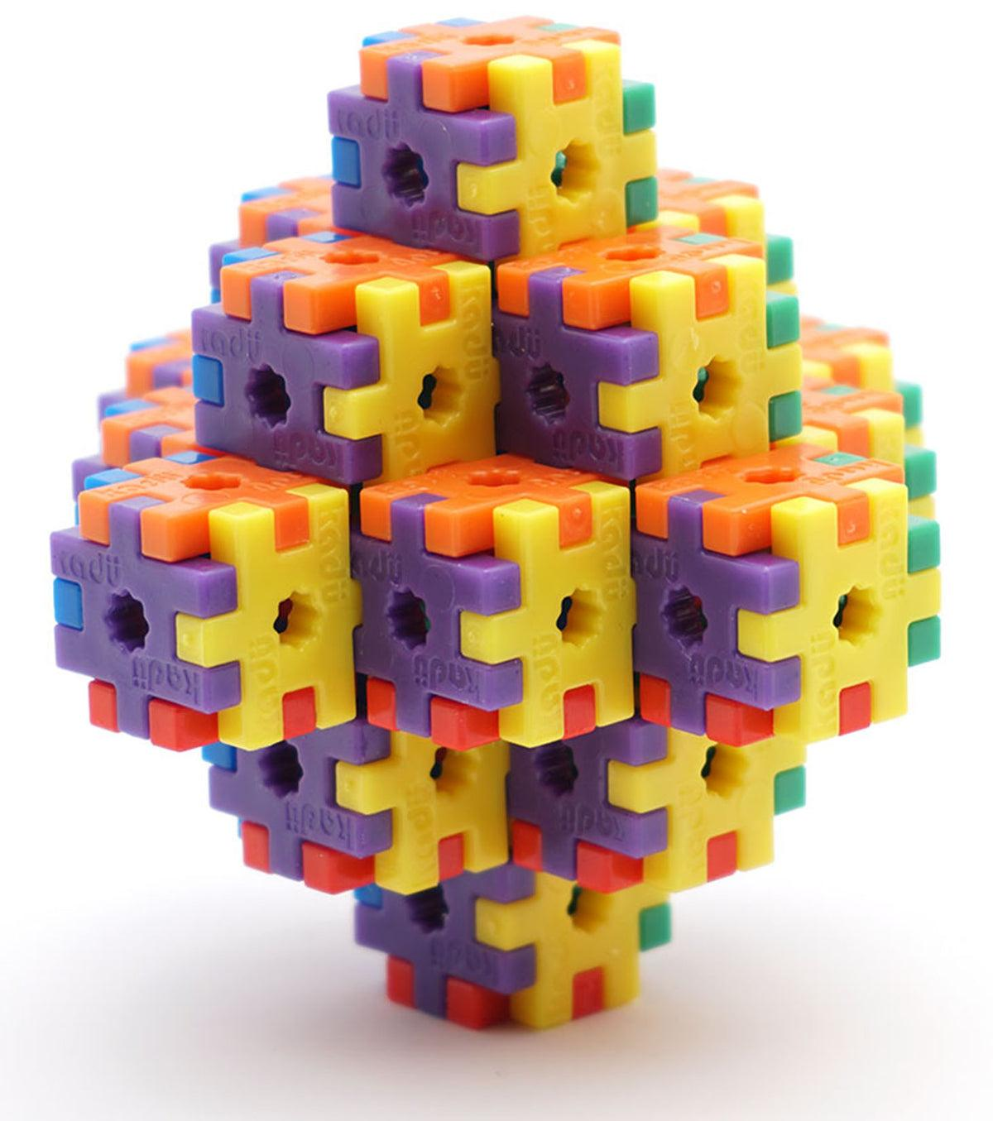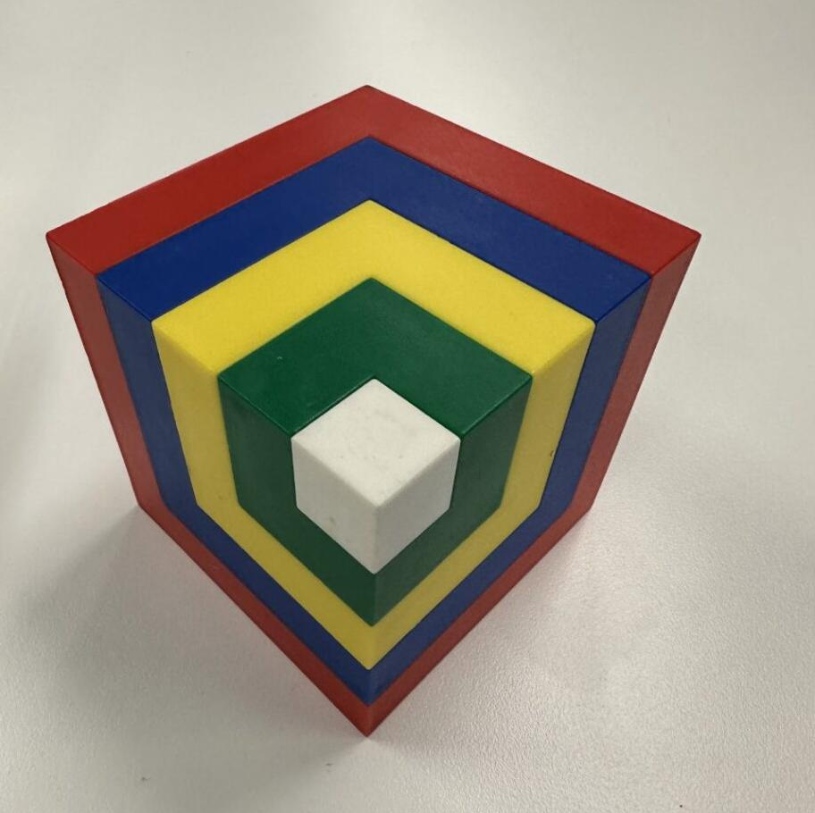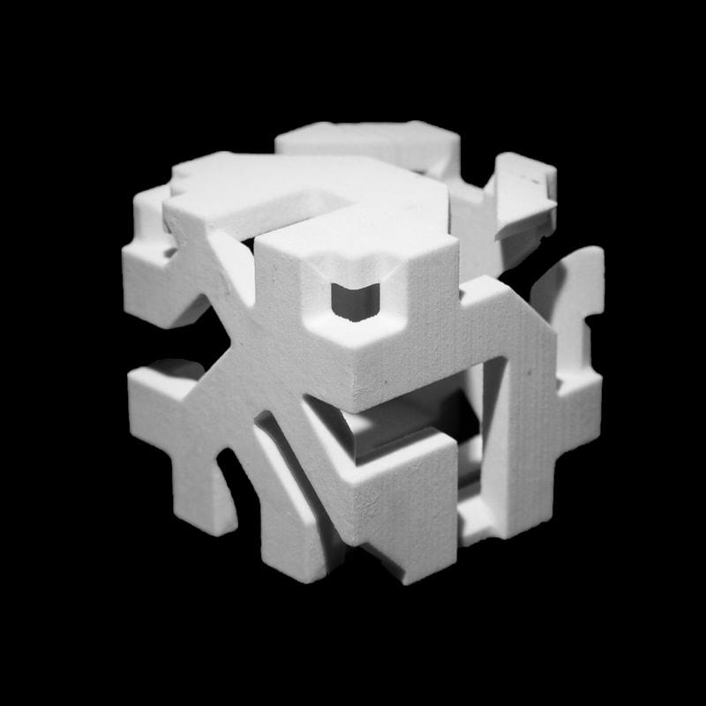
Important: Face-connected modules can form a single connected solid. Edge-connected and vertex-connected modules may touch without sharing a surface area, and therefore may not form a physically unified solid unless additional connections are present.

Classification by Module Configuration
# Source: AI Source: Provided by: [Data Path: Persons Table -> ID Column: 1, Name_En Column: Motasem Essam] -> From: [ChatGPT] on [7/25/2026]
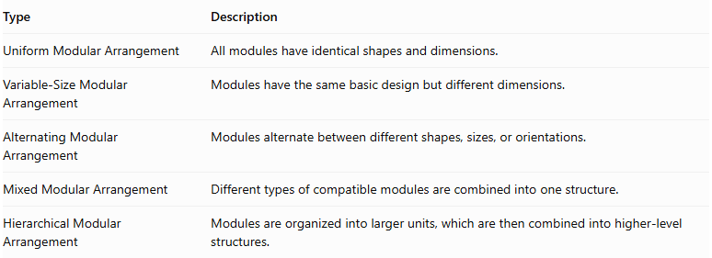
Type | Description
Uniform Modular Arrangement | All modules have identical shapes and dimensions.
Variable-Size Modular Arrangement | Modules have the same basic design but different dimensions.
Alternating Modular Arrangement | Modules alternate between different shapes, sizes, or orientations.
Mixed Modular Arrangement | Different types of compatible modules are combined into one structure.
Hierarchical Modular Arrangement | Modules are organized into larger units, which are then combined into higher-level structures.
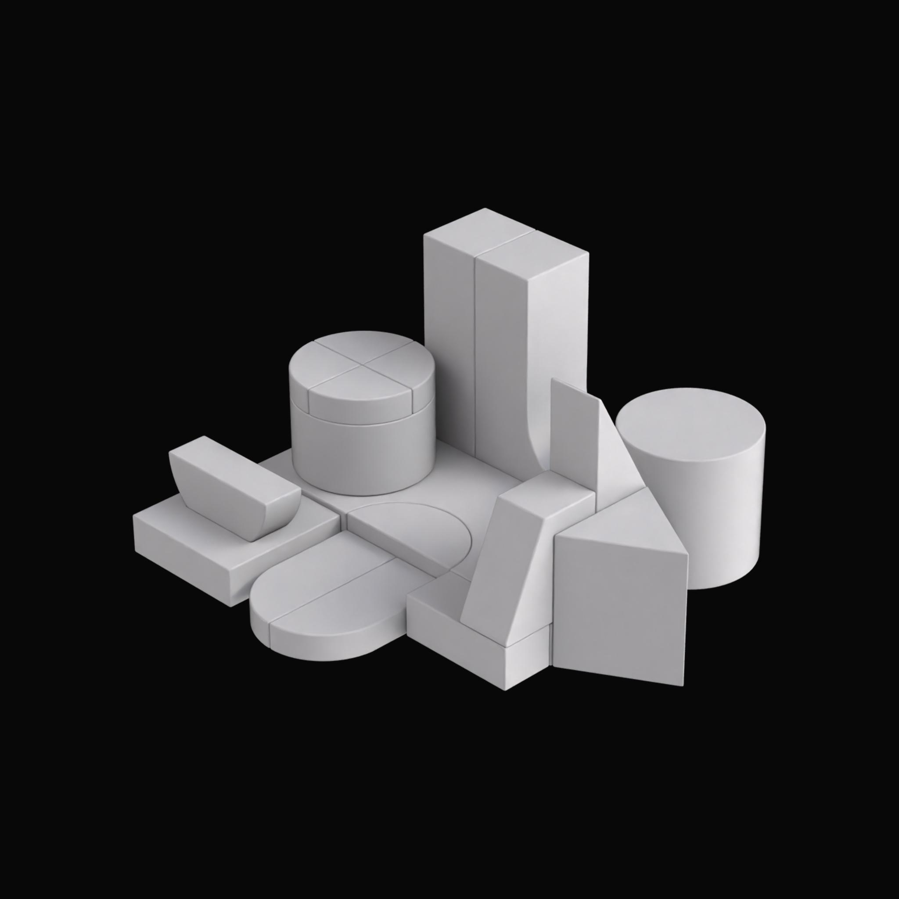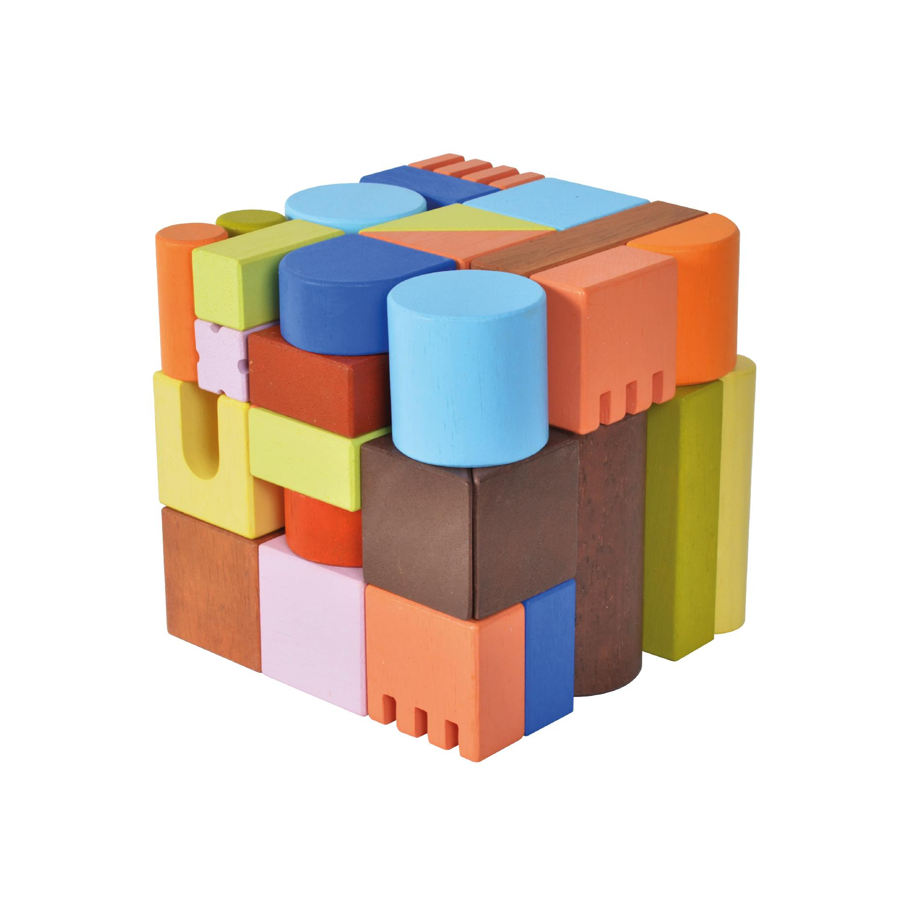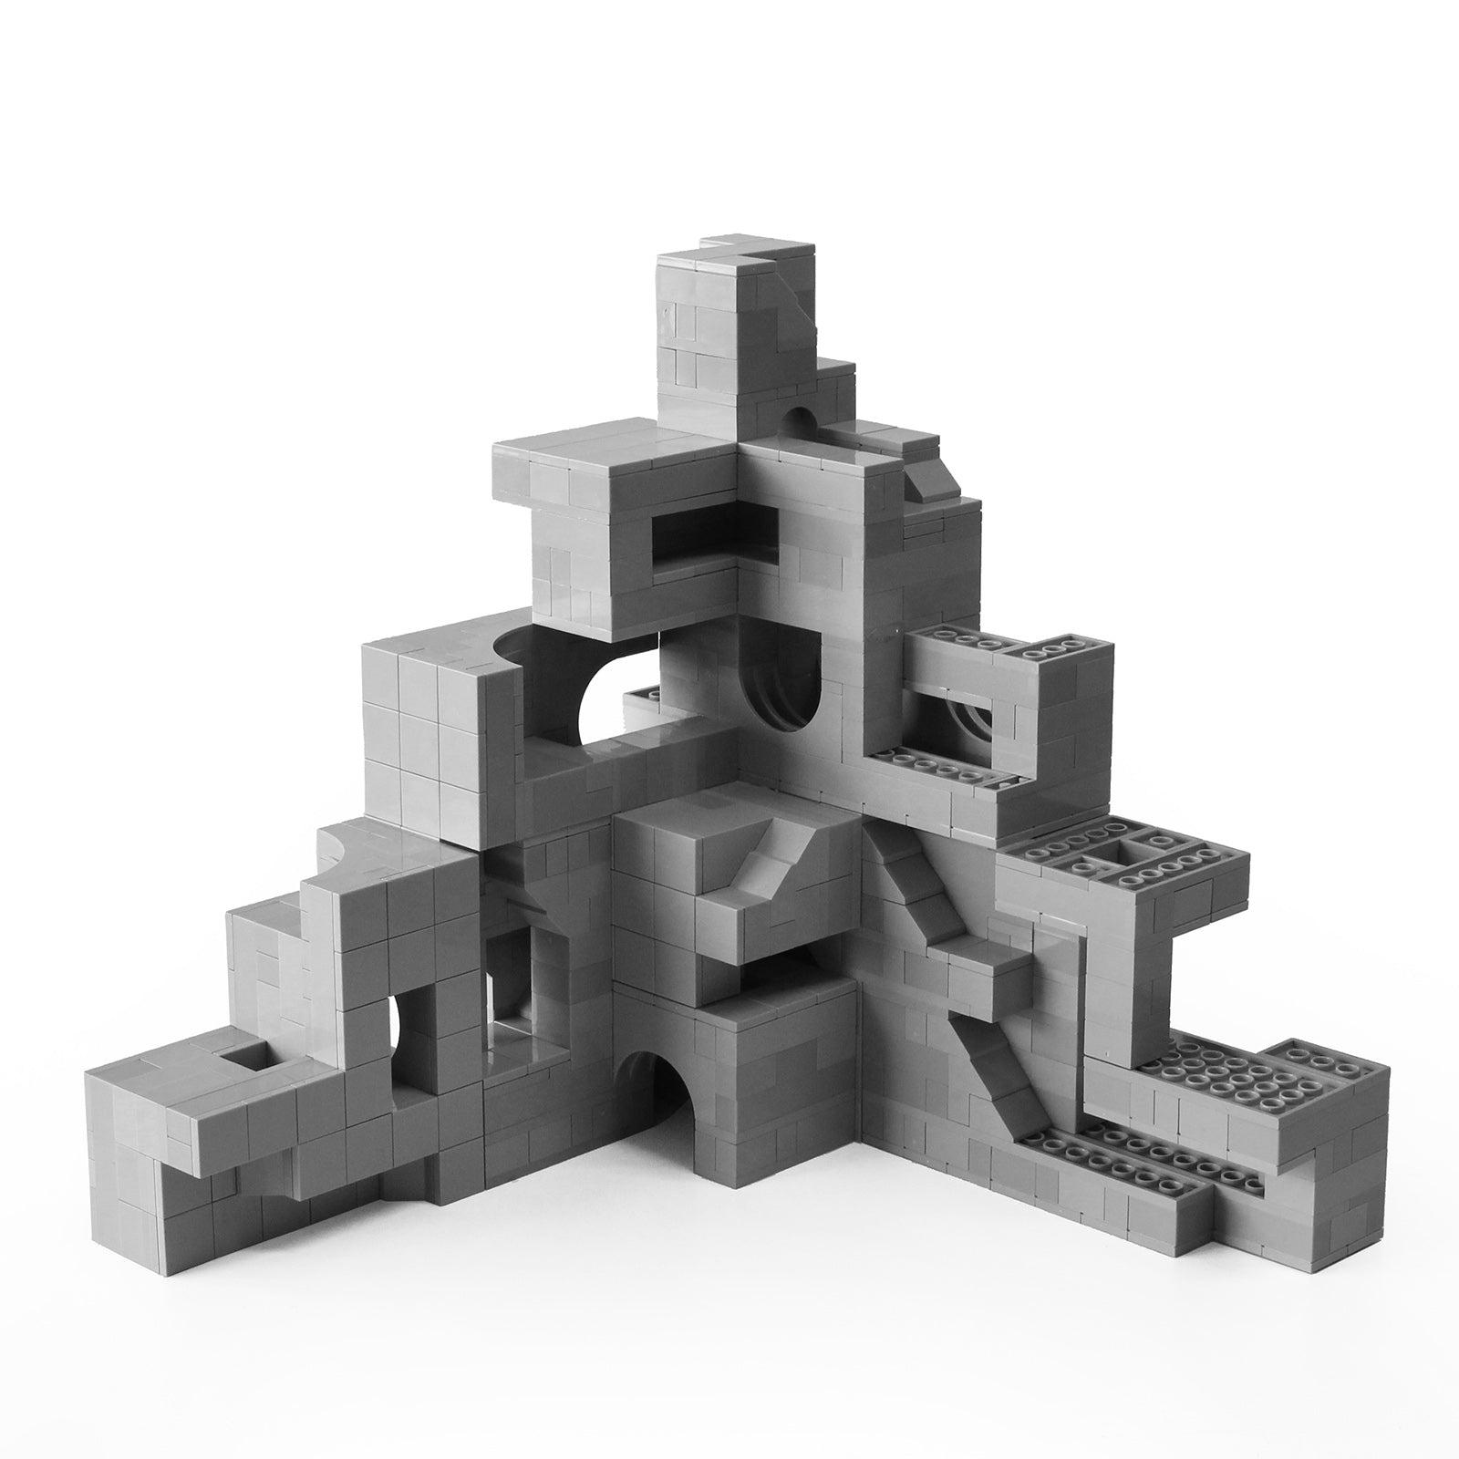

Classification by Arrangement Pattern
# Source: AI Source: Provided by: [Data Path: Persons Table -> ID Column: 1, Name_En Column: Motasem Essam] -> From: [ChatGPT] on [7/25/2026]
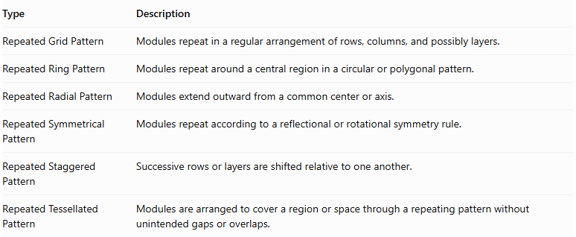
Type | Description
Repeated Grid Pattern | Modules repeat in a regular arrangement of rows, columns, and possibly layers.
Repeated Ring Pattern | Modules repeat around a central region in a circular or polygonal pattern.
Repeated Radial Pattern | Modules extend outward from a common center or axis.
Repeated Symmetrical Pattern | Modules repeat according to a reflectional or rotational symmetry rule.
Repeated Staggered Pattern | Successive rows or layers are shifted relative to one another.
Repeated Tessellated Pattern | Modules are arranged to cover a region or space through a repeating pattern without unintended gaps or overlaps.
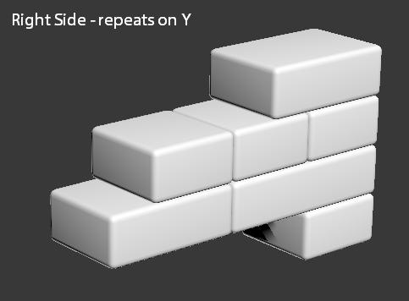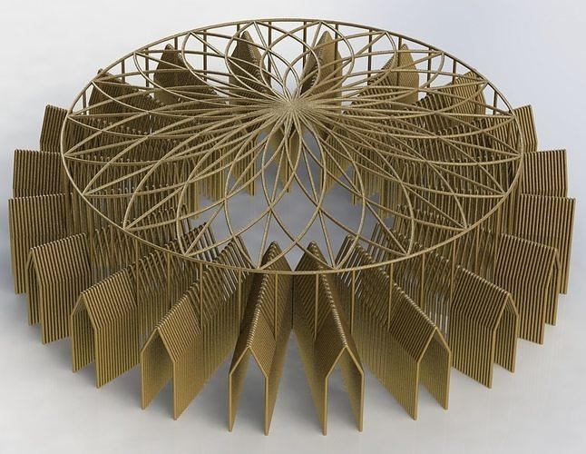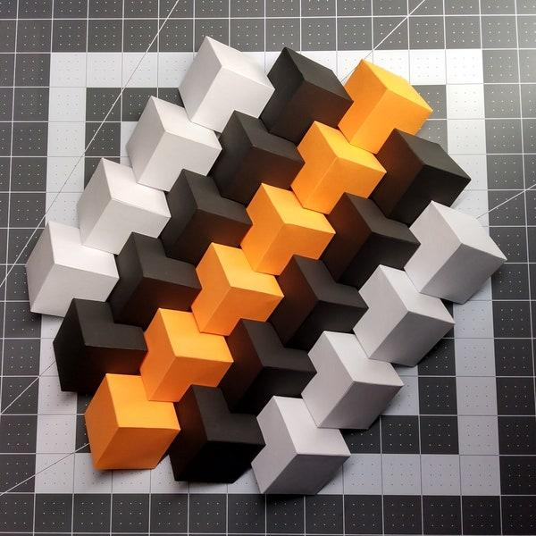

Classification by Module Orientation
# Source: AI Source: Provided by: [Data Path: Persons Table -> ID Column: 1, Name_En Column: Motasem Essam] -> From: [ChatGPT] on [7/25/2026]
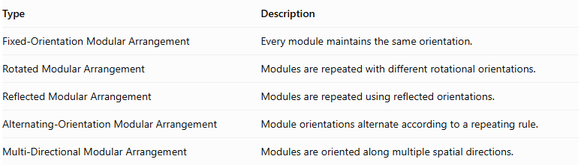
Type | Description
Fixed-Orientation Modular Arrangement | Every module maintains the same orientation.
Rotated Modular Arrangement | Modules are repeated with different rotational orientations.
Reflected Modular Arrangement | Modules are repeated using reflected orientations.
Alternating-Orientation Modular Arrangement | Module orientations alternate according to a repeating rule.
Multi-Directional Modular Arrangement | Modules are oriented along multiple spatial directions.
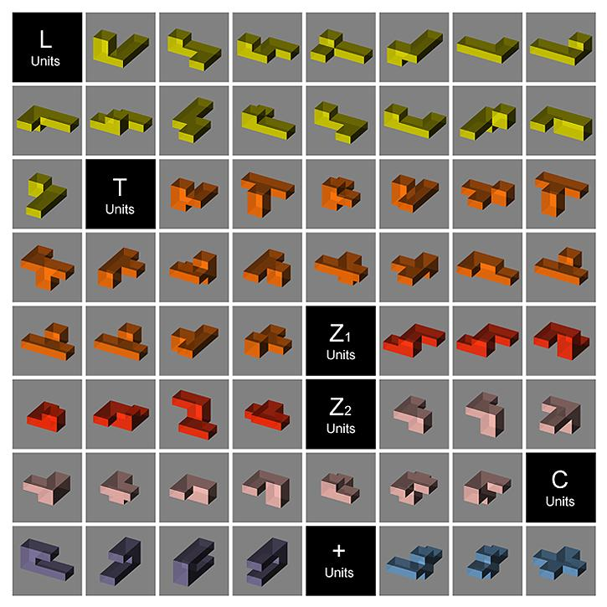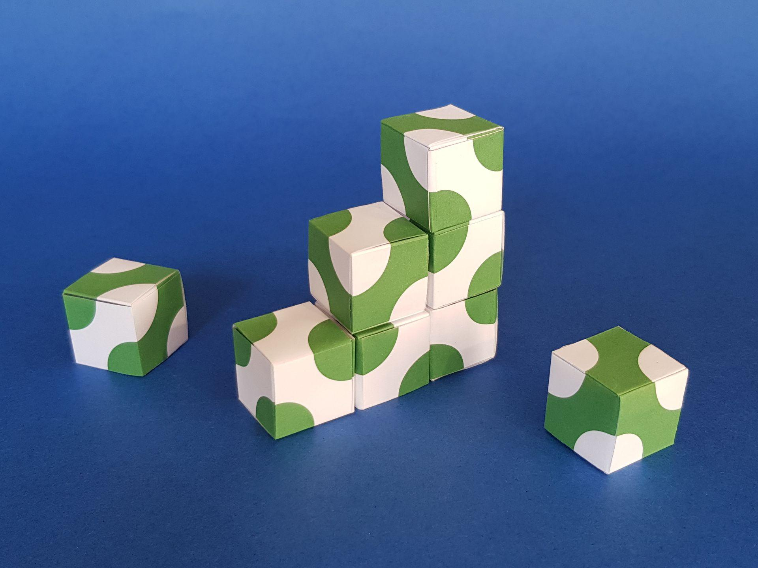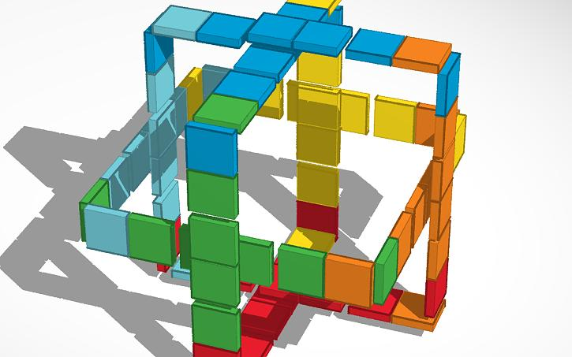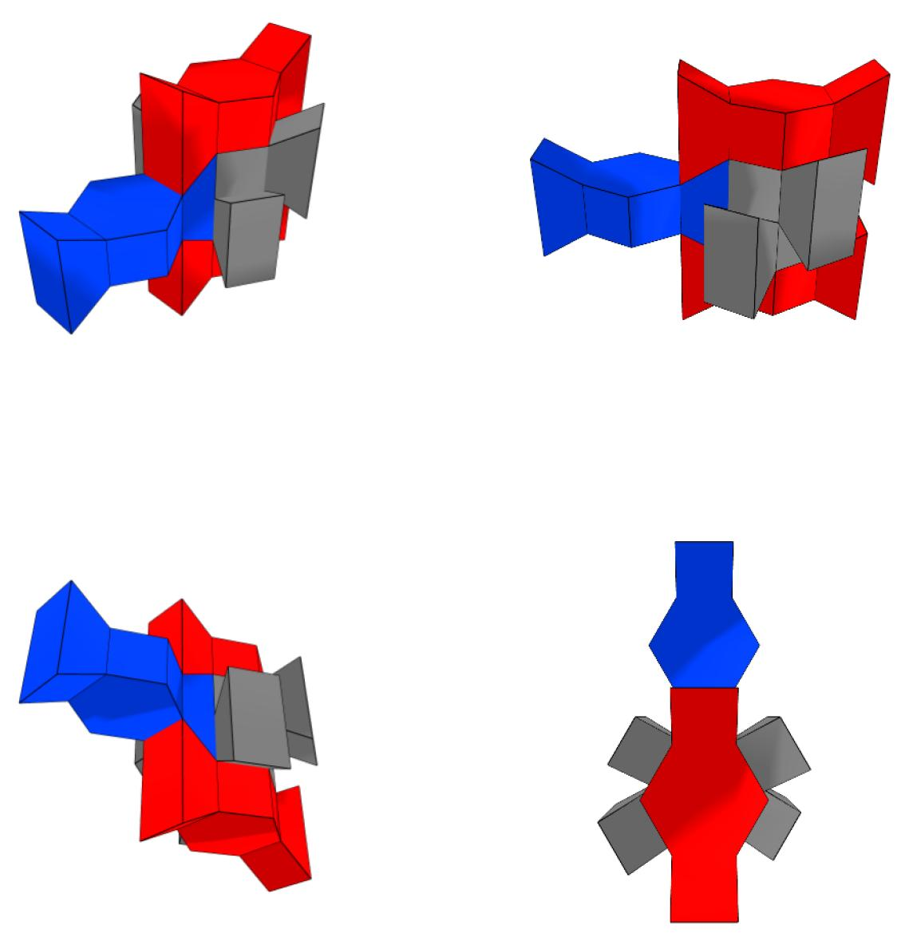

Classification by Module Shape
# Source: AI Source: Provided by: [Data Path: Persons Table -> ID Column: 1, Name_En Column: Motasem Essam] -> From: [ChatGPT] on [7/25/2026]
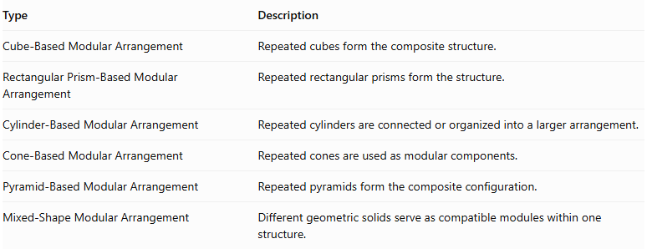
Type | Description
Cube-Based Modular Arrangement | Repeated cubes form the composite structure.
Rectangular Prism-Based Modular Arrangement | Repeated rectangular prisms form the structure.
Cylinder-Based Modular Arrangement | Repeated cylinders are connected or organized into a larger arrangement.
Cone-Based Modular Arrangement | Repeated cones are used as modular components.
Pyramid-Based Modular Arrangement | Repeated pyramids form the composite configuration.
Mixed-Shape Modular Arrangement | Different geometric solids serve as compatible modules within one structure.
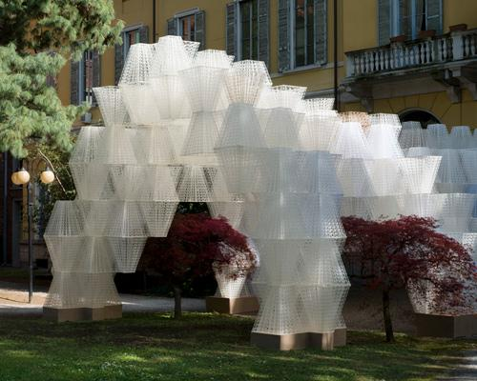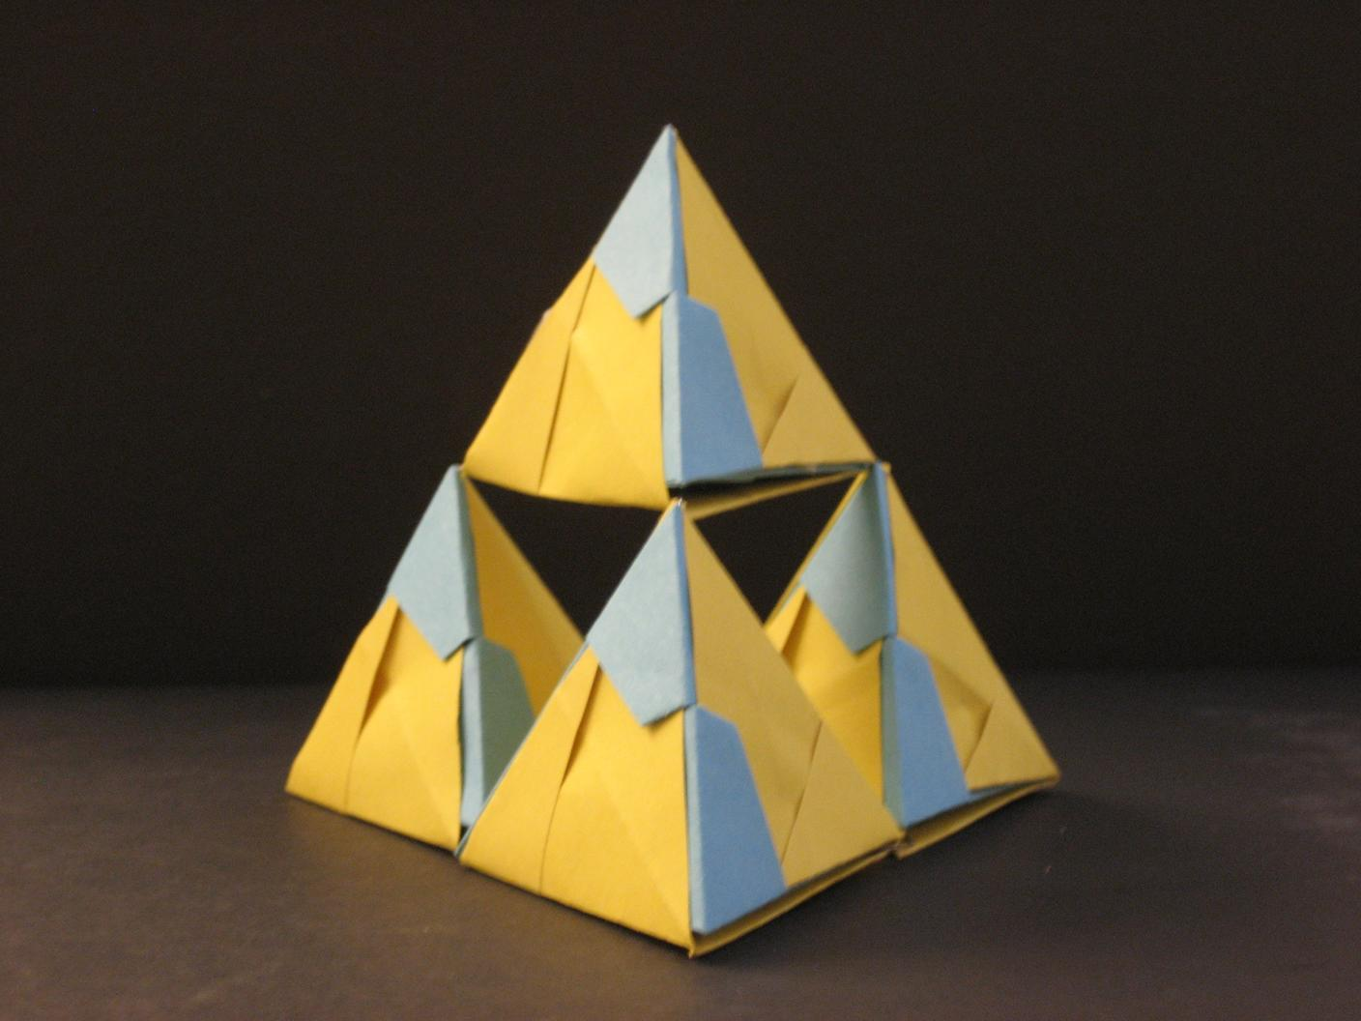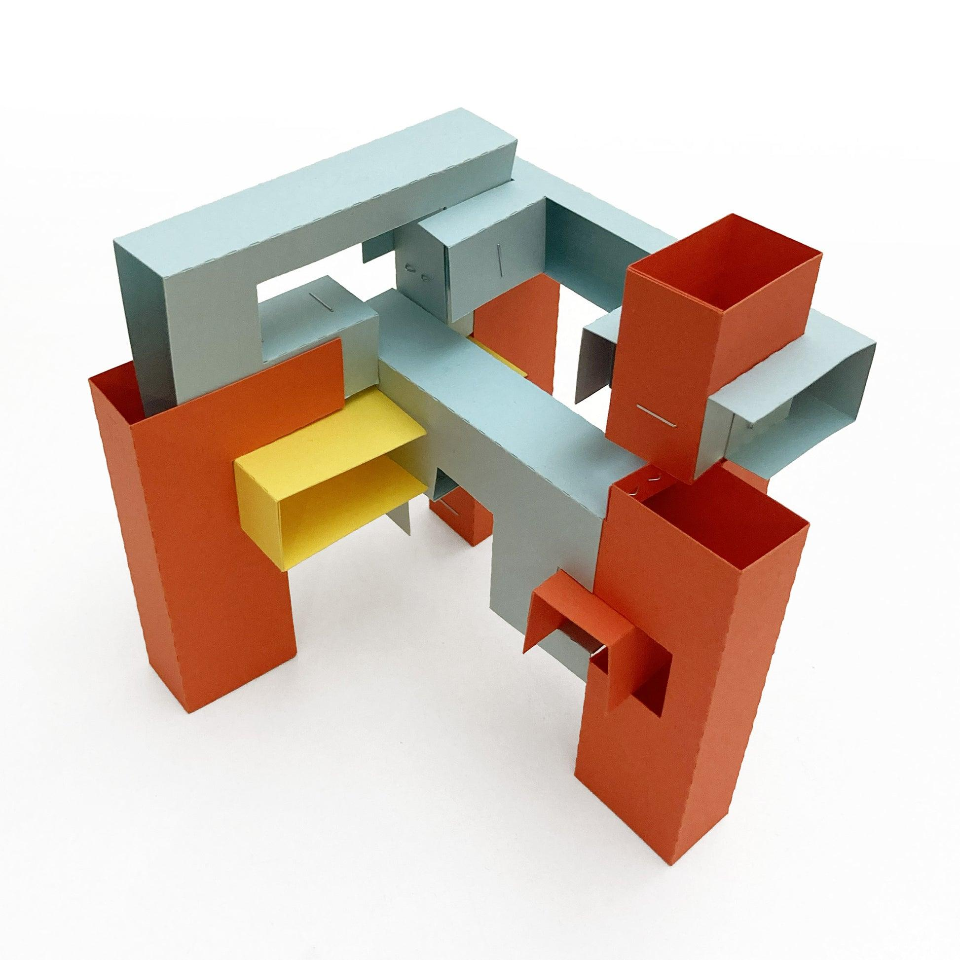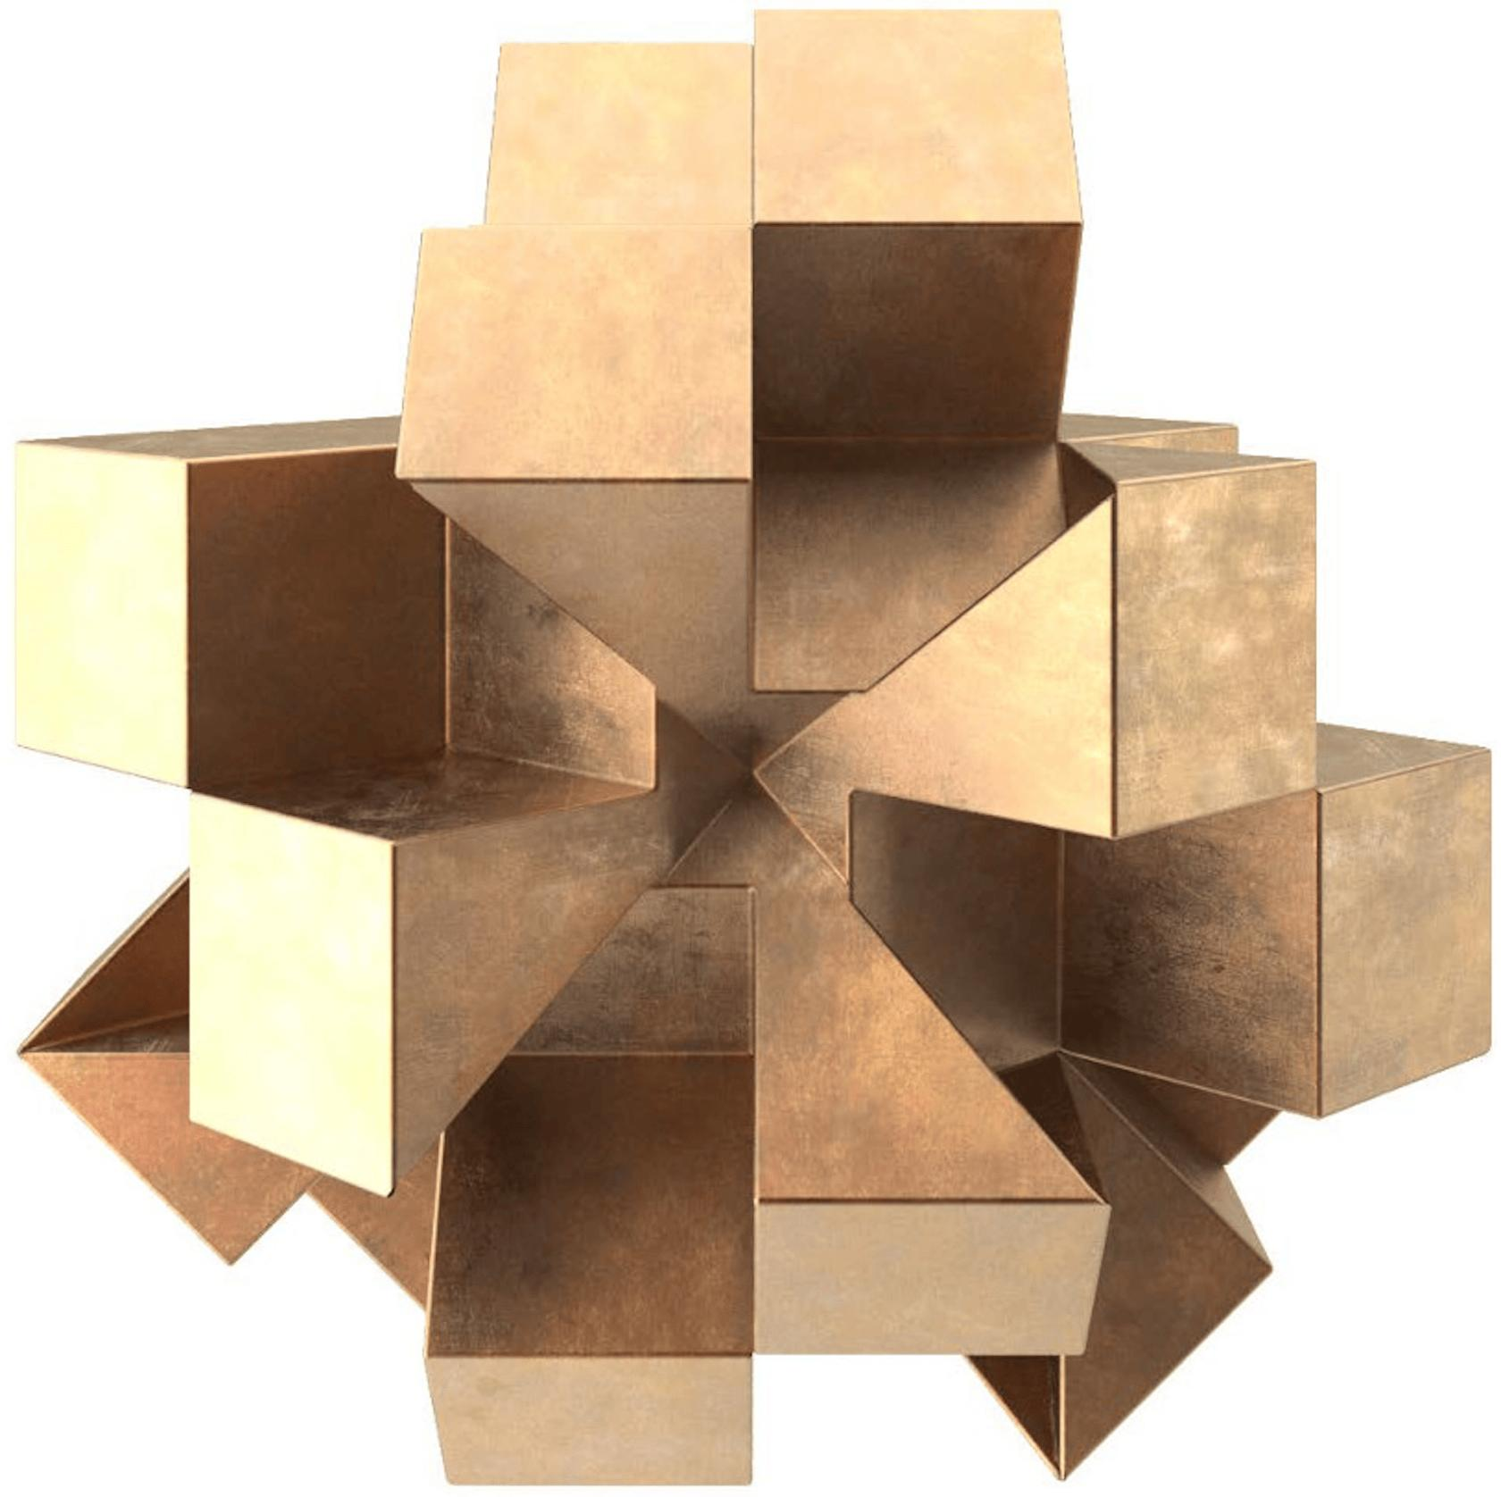

Mathematical Properties and Formulas

Total Number of Modules
# Source: AI Source: Provided by: [Data Path: Persons Table -> ID Column: 1, Name_En Column: Motasem Essam] -> From: [ChatGPT] on [7/25/2026]
For an arrangement containing $n$ identical modules:
$$\boxed{N_{total}=n}$$
For a three-dimensional regular arrangement with rows, columns, and layers:
$$\boxed{N_{total}=R×C×L}$$
Where:
- $R$ = Number of rows.
- $C$ = Number of columns.
- $L$ = Number of layers.

Total Volume
# Source: AI Source: Provided by: [Data Path: Persons Table -> ID Column: 1, Name_En Column: Motasem Essam] -> From: [ChatGPT] on [7/25/2026]
For non-overlapping modules:
$$\boxed{V_{total}={nV}_{m}}$$
Where:
- $n$ = Number of modules.
- $V_{m}$ = Volume of one module.
For different module types:
$$\boxed{V_{total}=\sum_{i=1}^{n}{V_{i}}}$$

Overall Dimensions
# Source: AI Source: Provided by: [Data Path: Persons Table -> ID Column: 1, Name_En Column: Motasem Essam] -> From: [ChatGPT] on [7/25/2026]
For identical rectangular modules with dimensions $l$, $w$, and $h$, arranged in a regular three-dimensional grid without gaps:
$$\boxed{L_{total}=Cl}$$
$$\boxed{W_{total}=Rw}$$
$$\boxed{H_{total}=Lh}$$
If equal gaps separate modules:
$$L_{total}=Cl+(C-1)g_{x}$$
$$W_{total}=Rw+(R-1)g_{y}$$
$$H_{total}=Lh+(L-1)g_{z}$$

External Surface Area
# Source: AI Source: Provided by: [Data Path: Persons Table -> ID Column: 1, Name_En Column: Motasem Essam] -> From: [ChatGPT] on [7/25/2026]
For face-connected modules, external surface area is determined by counting the exposed faces.
For $n$ identical cubic modules with side length $s$:
$${SA}_{external}=6{ns}^{2}-2{ks}^{2}$$
Where:
- $n$ = Number of cubes.
- $k$ = Number of complete shared face pairs.
- $s$ = Cube side length.
Each shared face pair removes two exposed square faces from the total surface area.
For more complicated modules, calculate the actual exposed surfaces and exclude hidden contact regions.

Worked Examples

Example 1: Repeated Modular Arrangement of Cubes
# Source: AI Source: Provided by: [Data Path: Persons Table -> ID Column: 1, Name_En Column: Motasem Essam] -> From: [ChatGPT] on [7/25/2026]
Problem:
A composite solid is constructed using 12 identical cubic modules arranged in three rows and four columns in a single layer.
Each cube has a side length of 3 cm. All cubes are connected face-to-face.
Calculate:
- The total number of modules.
- The total volume.
- The overall dimensions.
- The external surface area.
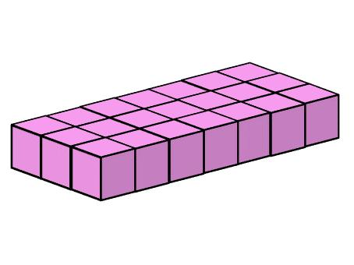
Step 1: Calculate the total number of modules.
$$N=3×4=12$$
Step 2: Calculate the volume of one module.
$$V_{m}=s^{3}$$
$$V_{m}=3^{3}=27{ cm}^{3}$$
Step 3: Calculate the total volume.
$$V_{total}=12×27$$
$$\boxed{V_{total}=324{ cm}^{3}}$$
Step 4: Calculate the overall dimensions.
Length:
$$L=4×3=12 cm$$
Width:
$$W=3×3=9 cm$$
Height:
$$H=1×3=3 cm$$
Therefore:
$$\boxed{12×9×3 cm}$$
Step 5: Calculate the external surface area.
The modules form a rectangular prism:
$$SA=2(lw+lh+wh)$$
$$SA=2(12×9+12×3+9×3)$$
$$SA=2(108+36+27)$$
$$\boxed{SA=342{ cm}^{2}}$$

Example 2: Three-Dimensional Modular Arrangement of Rectangular Prisms
# Source: AI Source: Provided by: [Data Path: Persons Table -> ID Column: 1, Name_En Column: Motasem Essam] -> From: [ChatGPT] on [7/25/2026]
Problem:
A composite solid consists of 12 identical rectangular prism modules arranged in two rows, three columns, and two layers.
Each module has dimensions:
- Length = 4 cm.
- Width = 3 cm.
- Height = 2 cm.
All modules are connected face-to-face without gaps.
Calculate:
- The total number of modules.
- The total volume.
- The overall dimensions.
- The external surface area.
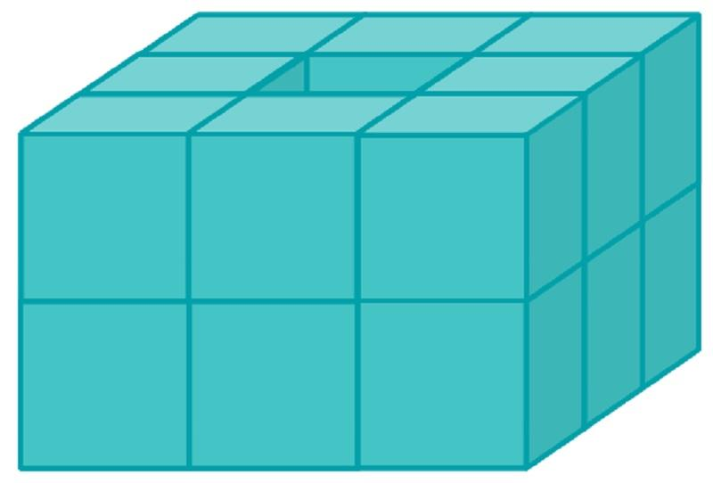
Step 1: Calculate the total number of modules.
$$N=2×3×2$$
$$\boxed{N=12}$$
Step 2: Calculate the volume of one module.
$$V_{m}=lwh$$
$$V_{m}=4×3×2$$
$$V_{m}=24{ cm}^{3}$$
Step 3: Calculate the total volume.
$$V_{total}=12×24$$
$$\boxed{V_{total}=288{ cm}^{3}}$$
Step 4: Calculate the overall dimensions.
Length:
$$L=3×4=12 cm$$
Width:
$$W=2×3=6 cm$$
Height:
$$H=2×2=4 cm$$
Therefore:
$$\boxed{12×6×4 cm}$$
Step 5: Calculate the external surface area.
$$SA=2(lw+lh+wh)$$
$$SA=2(12×6+12×4+6×4)$$
$$SA=2(72+48+24)$$
$$\boxed{SA=288{ cm}^{2}}$$

Important Characteristics
# Source: AI Source: Provided by: [Data Path: Persons Table -> ID Column: 1, Name_En Column: Motasem Essam] -> From: [ChatGPT] on [7/25/2026]
- The arrangement is constructed from repeated geometric modules.
- Modules may be identical or compatible with one another.
- Each module acts as a basic building unit.
- Modules may be connected through faces, edges, vertices, or specialized interfaces.
- Repetition may occur in one, two, or three spatial directions.
- Modules may maintain identical orientations or use different orientations.
- The overall structure may be regular, symmetrical, staggered, or irregular.
- Modular arrangements can be expanded by adding more units.
- Total volume is the sum of module volumes when there is no overlap.
- External surface area depends on the exposed surfaces and connections between modules.

Comparison with Other Component Arrangements
# Source: AI Source: Provided by: [Data Path: Persons Table -> ID Column: 1, Name_En Column: Motasem Essam] -> From: [ChatGPT] on [7/25/2026]
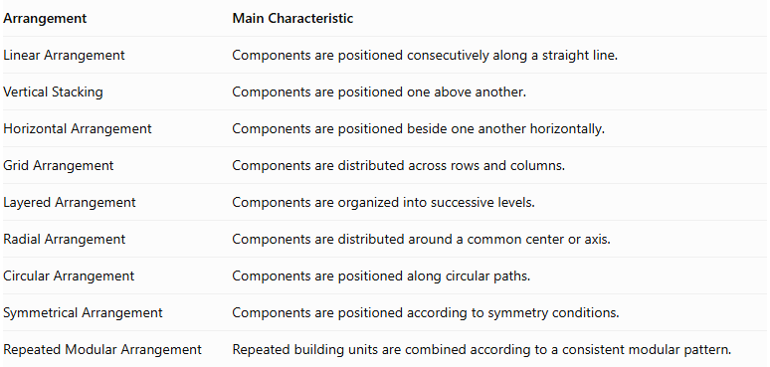
Arrangement | Main Characteristic
Linear Arrangement | Components are positioned consecutively along a straight line.
Vertical Stacking | Components are positioned one above another.
Horizontal Arrangement | Components are positioned beside one another horizontally.
Grid Arrangement | Components are distributed across rows and columns.
Layered Arrangement | Components are organized into successive levels.
Radial Arrangement | Components are distributed around a common center or axis.
Circular Arrangement | Components are positioned along circular paths.
Symmetrical Arrangement | Components are positioned according to symmetry conditions.
Repeated Modular Arrangement | Repeated building units are combined according to a consistent modular pattern.
Repeated Modular vs. Grid Arrangement: A grid arrangement describes the spatial distribution of components across rows and columns. A repeated modular arrangement describes the use of repeated building units. A modular arrangement can use a grid pattern, but it can also use circular, radial, linear, or other patterns.
Repeated Modular vs. Layered Arrangement: A layered arrangement focuses on the organization of components into successive levels, while a repeated modular arrangement focuses on repeating compatible building units. A modular structure may contain multiple layers.

Real-World Applications
# Source: AI Source: Provided by: [Data Path: Persons Table -> ID Column: 1, Name_En Column: Motasem Essam] -> From: [ChatGPT] on [7/25/2026]
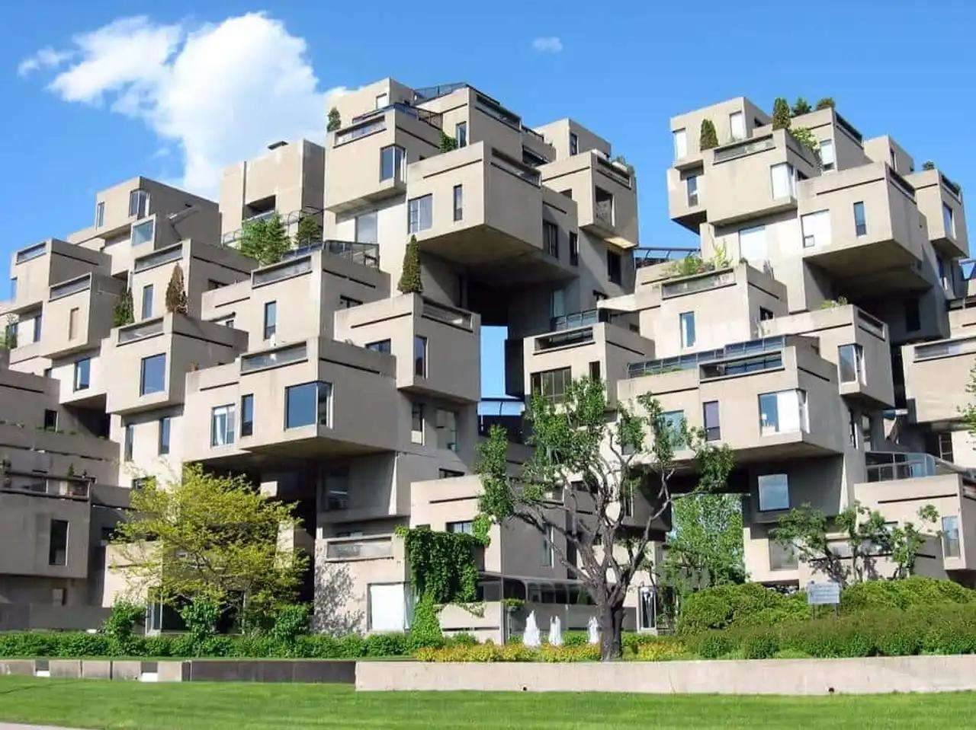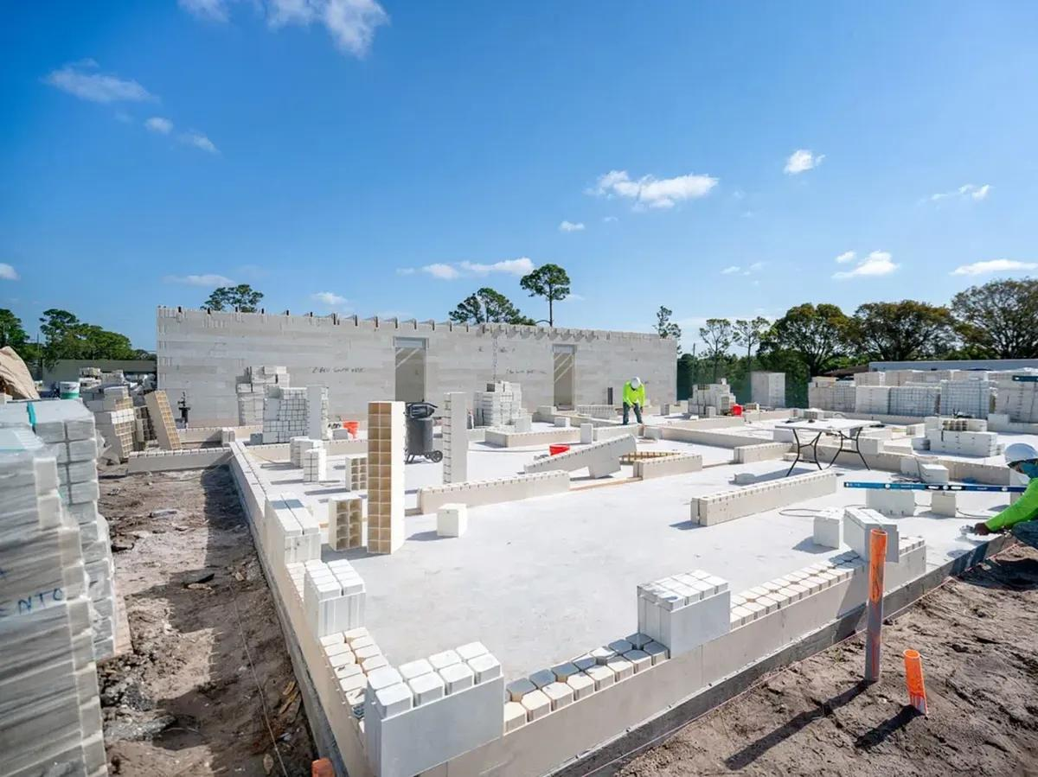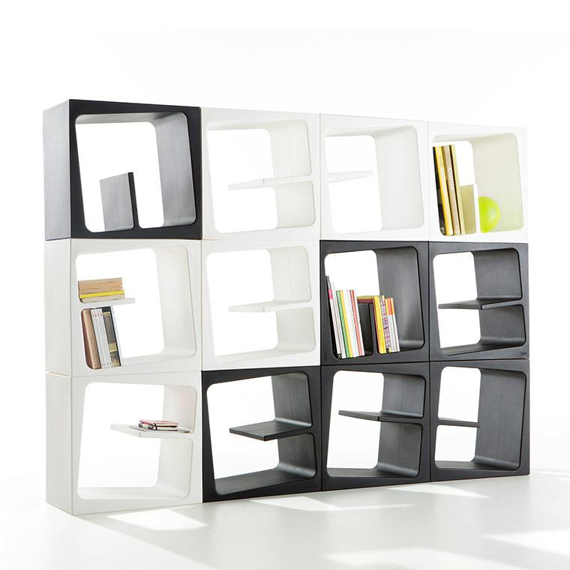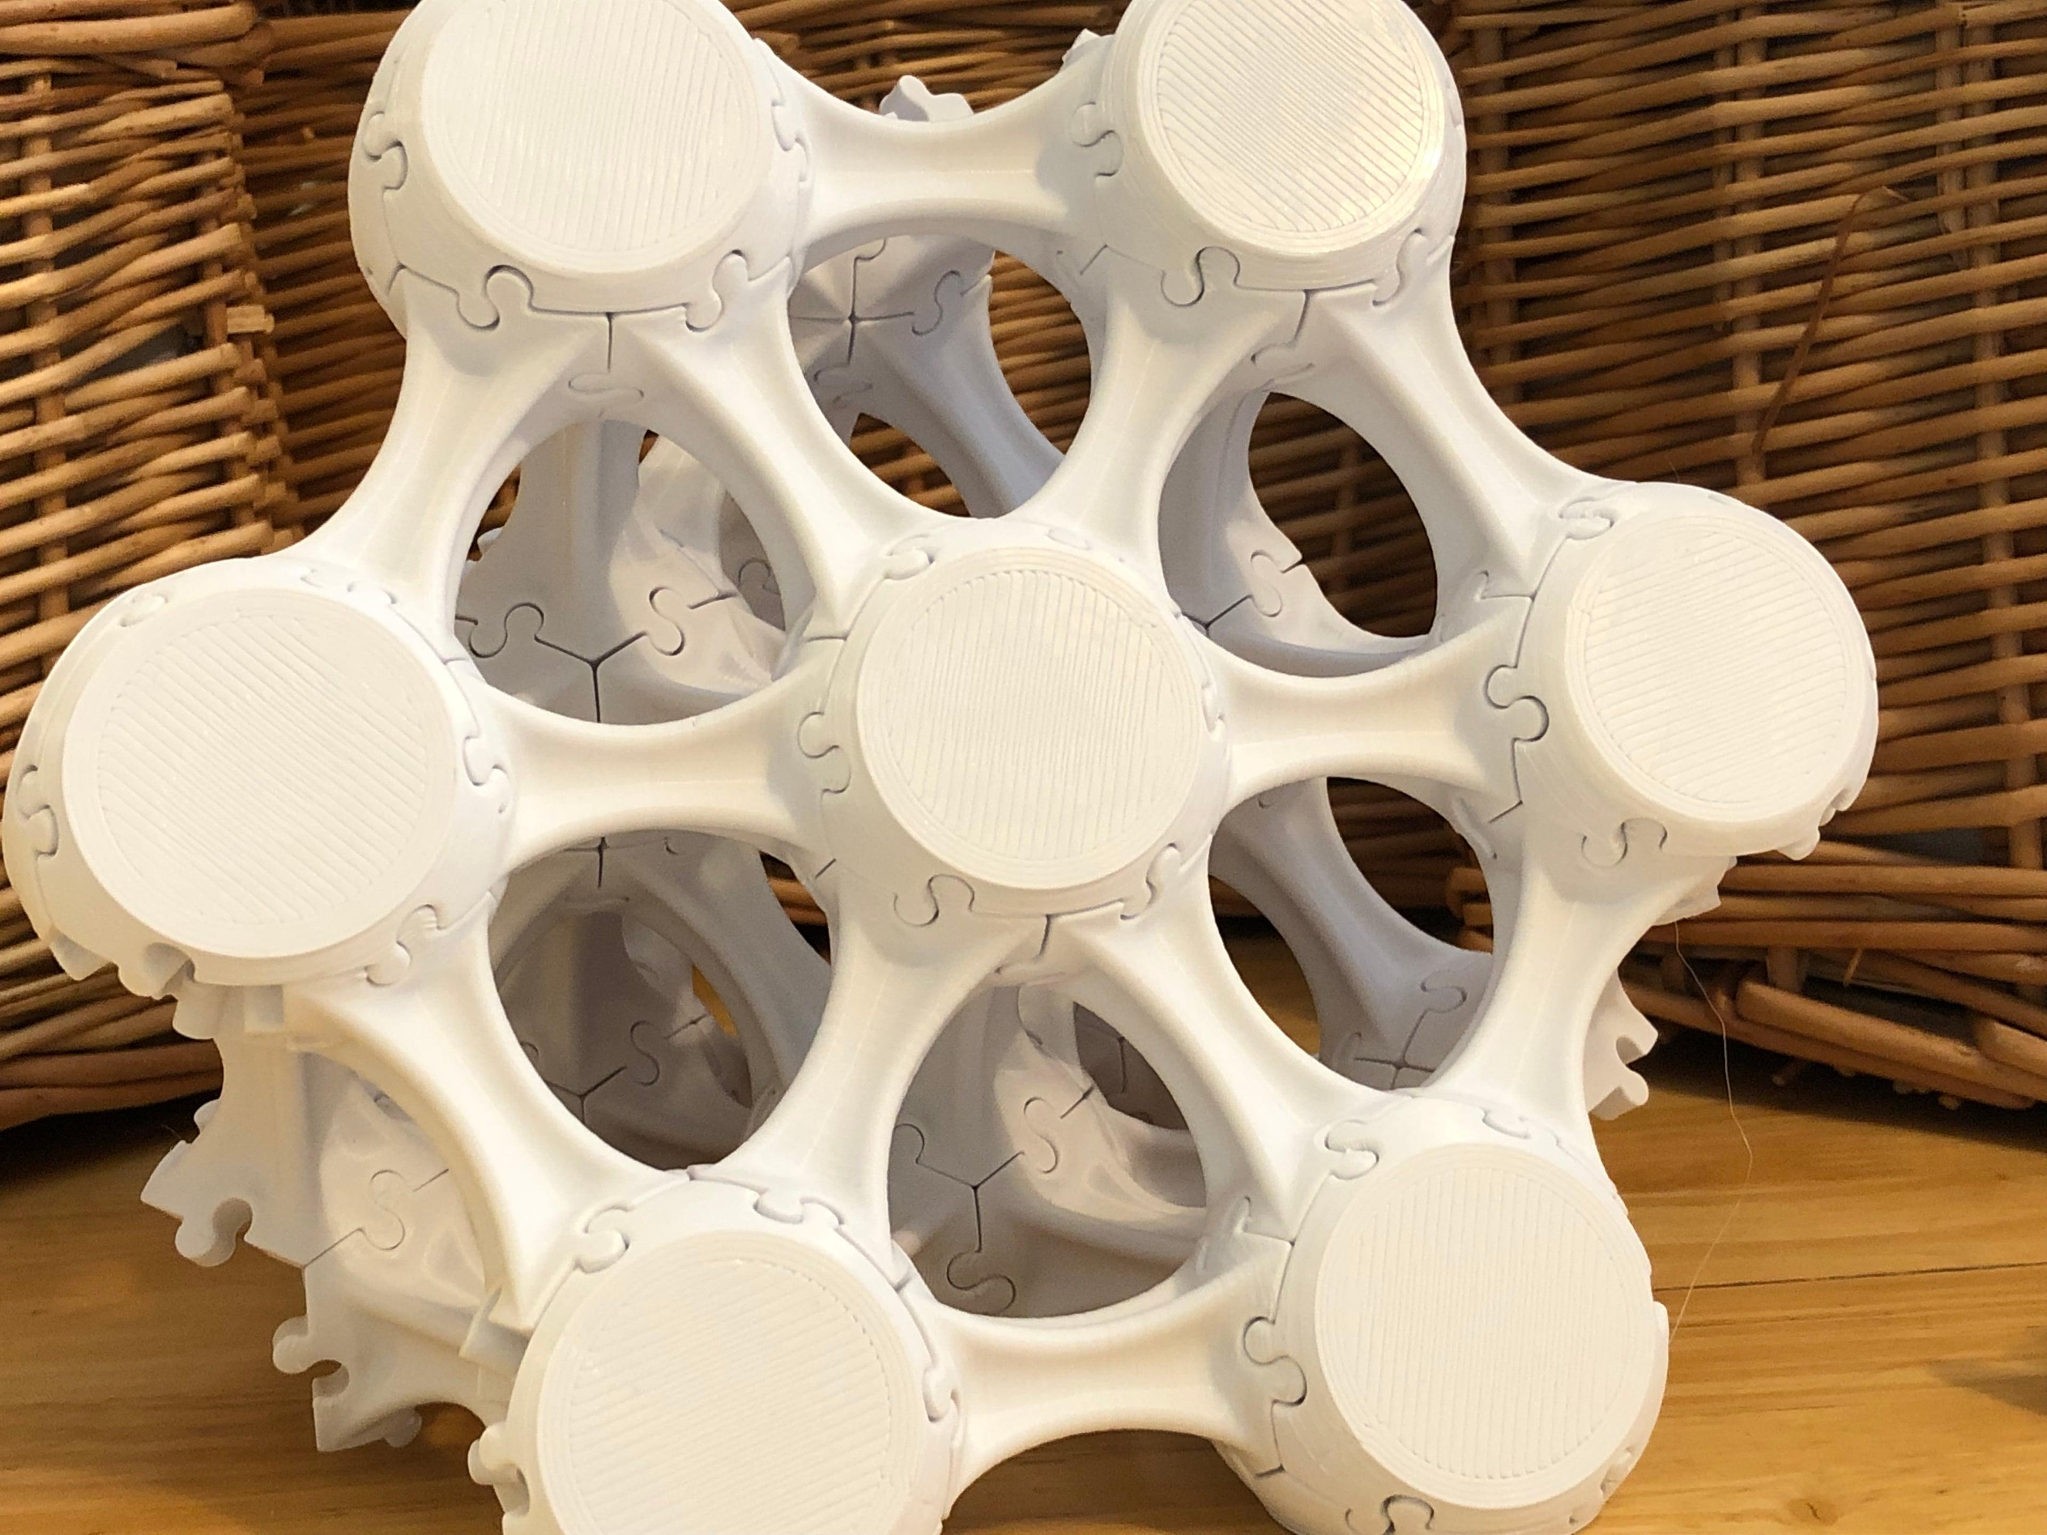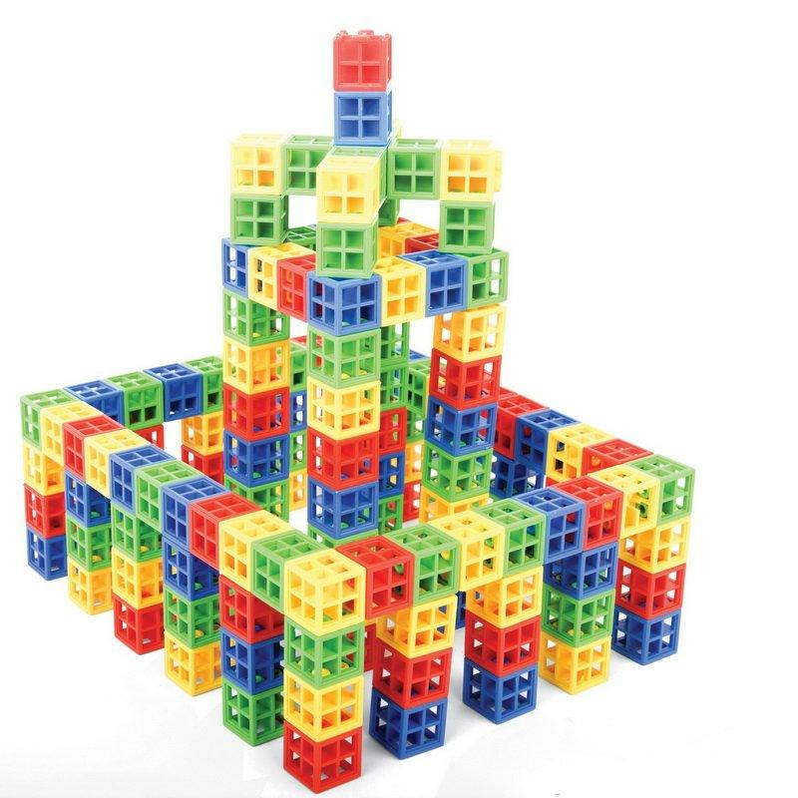
- Architecture: Buildings assembled from repeated structural modules.
- Construction: Modular blocks and prefabricated building components.
- Manufacturing: Products assembled from standardized repeated parts.
- Furniture Design: Modular shelves, cabinets, and storage systems.
- Mechanical Engineering: Repeated mechanical units connected into larger assemblies.
- 3D Printing: Structures constructed by repeating a basic geometric unit.
- Mathematical Modeling: Studying volume, surface area, spatial repetition, and geometric patterns.

Key Points
# Source: AI Source: Provided by: [Data Path: Persons Table -> ID Column: 1, Name_En Column: Motasem Essam] -> From: [ChatGPT] on [7/25/2026]
- A repeated modular arrangement uses repeated building units to create a larger structure.
- Each module acts as a basic geometric component.
- Modules may be identical or compatible in shape and connection design.
- Repetition may occur along one, two, or three spatial directions.
- Connection patterns include face-connected, edge-connected, vertex-connected, and interlocking arrangements.
- Modular structures may use grid, circular, radial, layered, or symmetrical patterns.
- Total volume is the sum of module volumes when there is no overlap.
- External surface area depends on the exposed surfaces after assembly.

Conclusion
# Source: AI Source: Provided by: [Data Path: Persons Table -> ID Column: 1, Name_En Column: Motasem Essam] -> From: [ChatGPT] on [7/25/2026]
A Repeated Modular Arrangement is a classification of composite solids based on constructing larger structures from repeated geometric building units. These units can be organized according to linear, grid, layered, radial, circular, or other spatial patterns.
Its main characteristic is modular repetition: a basic component or compatible set of components is reused to form a larger and potentially expandable three-dimensional structure.

